**EE 559**

**FINAL PROJECT**

BY

PRANAV GUNDEWAR

USC ID: 4463612994

EMAIL: [gundewar@usc.edu](mailto:gundewar@usc.edu)

ADITYA KILLEKAR

USC ID: 20514504147

EMAIL: [killekar@usc.edu](mailto:killekar@usc.edu)

GUIDED BY

PROF. B. KEITH JENKINS

Table of Contents

**Type chapter title (level 1)1**

Type chapter title (level 2)2

Type chapter title (level 3)3

**Type chapter title (level 1)4**

Type chapter title (level 2)5

Type chapter title (level 3)6

**DATA INTERPRETATION**

# **BANK MARKETING DATa set**

## **MARKETING INTRODUCTION**

The method by which companies make value for clients and construct solid client connections in arrange to capture value from clients in return.

Marketing campaigns are characterized by centering on the client needs and their overall fulfillment. In any case, there are distinctive factors that decide whether a promoting campaign will be effective or not. There are certain factors that we got to take into thought when making a marketing campaign.

The data is related with direct marketing campaigns of a Portuguese banking institution. The marketing campaigns were based on phone calls. Often, more than one contact to the same client was required, in order to access if the product (bank term deposit) would be ('yes') or not ('no') subscribed.

The classification goal is to predict if the client will subscribe (yes/no) a term deposit (variable y).

Written in Python with scikit-learn and pandas libraries.

Data are imported as pandas dataframe, filtered by intact records, encoded on categorical variables using onehot scheme, normalized using different scaler, and divided into training and testing datasets. Various machine learning algorithms have been implemented and their performance has been compared on the basis on different parameters.

## **ATTRIBUTE DESCRIPTION**

**I. Bank Client Data:**

1 - **age:** (numeric)  
2 - **job:** type of job (categorical: 'admin.','blue- collar','entrepreneur','housemaid','management','retired','self-employed','services','student','technician','unemployed','unknown')  
3 - **marital:** marital status (categorical: 'divorced','married','single','unknown'; note: 'divorced' means divorced or widowed)  
4 - **education:** (categorical: primary, secondary, tertiary and unknown)  
5 - **default:** has credit in default? (categorical: 'no','yes','unknown')  
6 - **housing:** has housing loan? (categorical: 'no','yes','unknown')  
7 - **loan:** has personal loan? (categorical: 'no','yes','unknown')  
8 - **balance:** Balance of the individual.

**II. Related with the last contact of the current campaign:**

8 - **contact:** contact communication type (categorical: 'cellular','telephone')   
9 - **month:** last contact month of year (categorical: 'jan', 'feb', 'mar', ..., 'nov', 'dec')  
10 - **day:** last contact day of the week (categorical: 'mon','tue','wed','thu','fri')

**III. Other Attributes:**

11 - **campaign:** number of contacts performed during this campaign and for this client (numeric, includes last contact)  
12 - **pdays:** number of days that passed by after the client was last contacted from a previous campaign (numeric; 999 means client was not previously contacted)  
13 - **previous:** number of contacts performed before this campaign and for this client (numeric)  
14 - **poutcome:** outcome of the previous marketing campaign (categorical: 'failure','nonexistent','success')

**IV. Social and Economic Context Attributes:**

15 - **emp.var.rate**: employment variation rate - quarterly indicator (numeric)   
16 - **cons.price.idx**: consumer price index - monthly indicator (numeric)   
17 - **cons.conf.idx**: consumer confidence index - monthly indicator (numeric)   
18 - **euribor3m**: euribor 3 month rate - daily indicator (numeric)   
19 - **nr.employed**: number of employees - quarterly indicator (numeric)

20 -**Subscription:** Has client subscribed a term deposit? – class labels (binary: 'no','yes')

## **DATA ANALYSIS AND VISUALIZATION**

For the given dataset, we can divide the features into continuous and categorical features.

Continuous Data: Index (['age', 'campaign', 'pdays', 'previous', 'emp.var.rate',

'cons.price.idx', 'cons.conf.idx', 'euribor3m', 'nr.employed'],

dtype='object')

Categorical Data: Index (['job', 'marital', 'education', 'housing', 'loan', 'contact', 'month',

'day\_of\_week', 'poutcome'],

dtype='object')

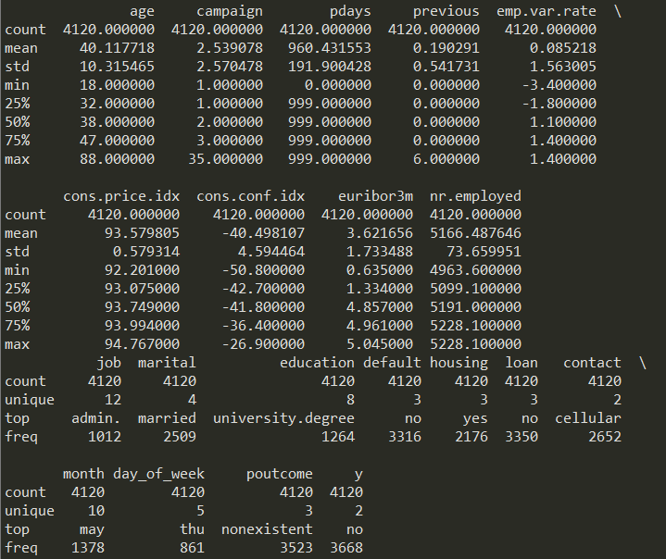

**Figure 1** – Data Description

From figure 1, we get the basic idea about type of data, its distribution. We can get the better idea using data plots.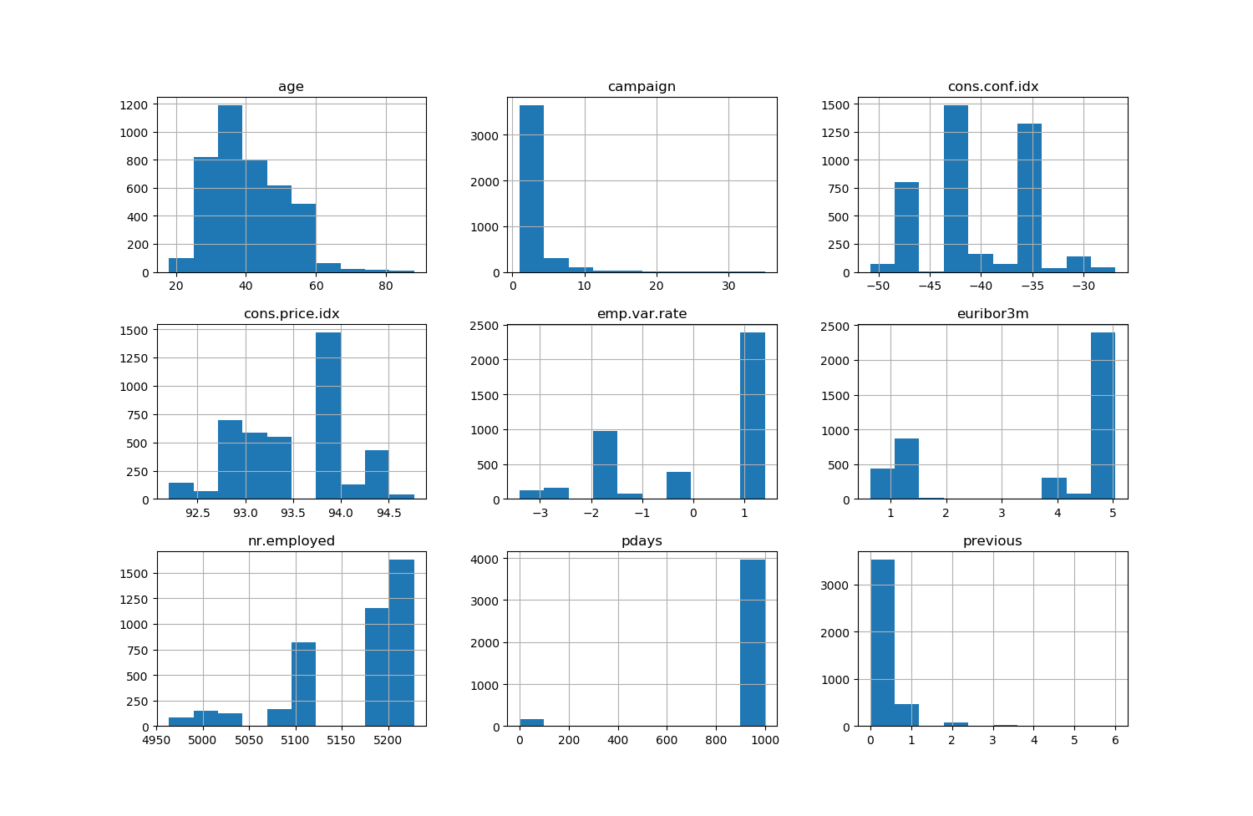

**Figure 2** – Histogram of Continuous Data

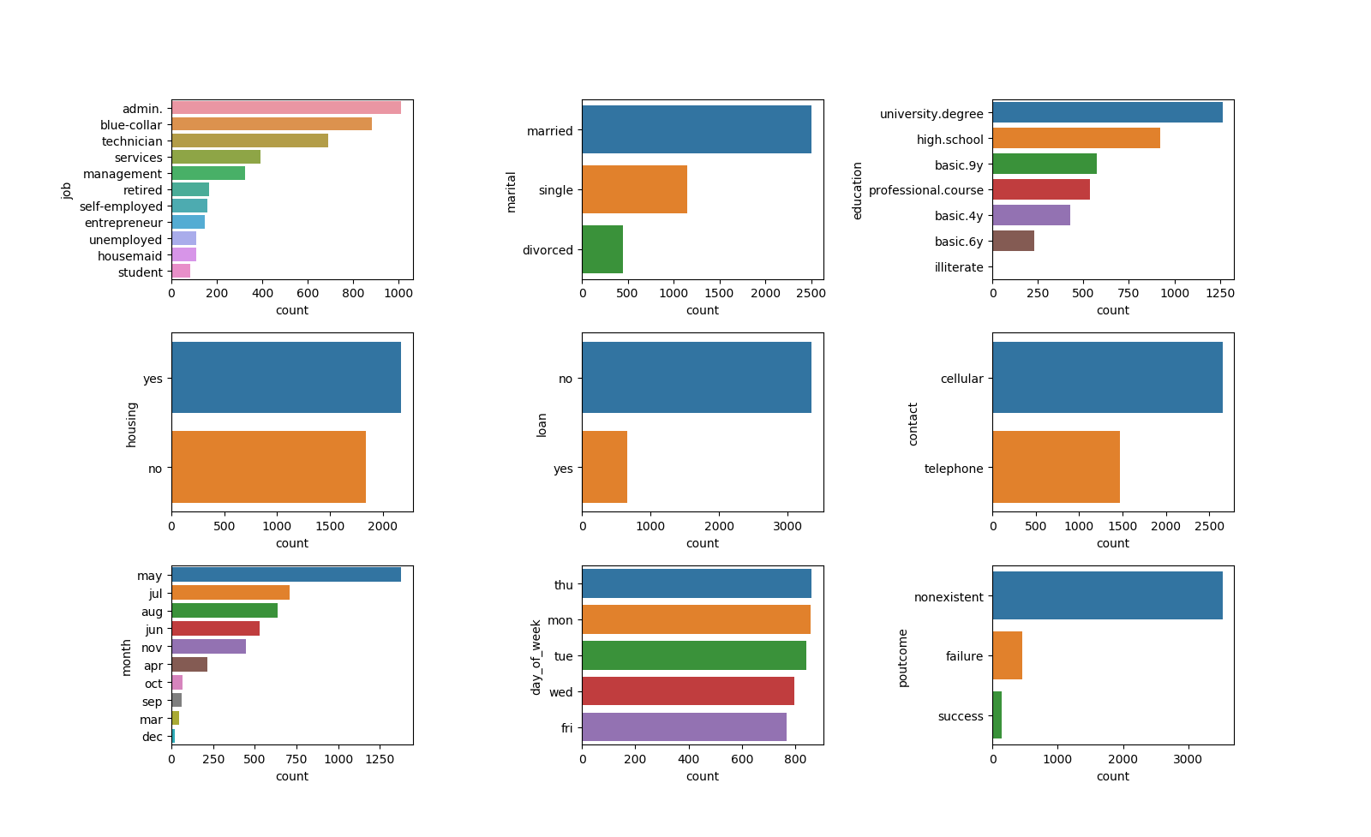

**Figure 3** – Count plot of Categorical Data

By analyzing visual plots from figure 2 and 3, we can decide what are the necessary steps required for pre-processing.

**Data Analysis:**

Questions to determine:

1. What **percentage(%)** of potential clients accepted to subscribe to term deposits vs refused to subscribe term deposits.
2. Is there a huge difference between clients that **subscribed term deposits vs refused deposits?**

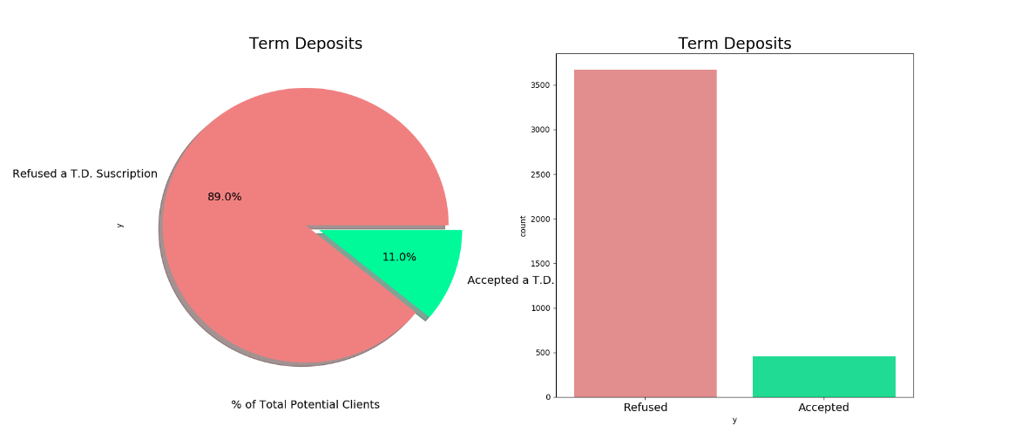

**Figure 4** – Class labels density

Summary:

**89% refused** to subscribe to term deposits while **11% accepted** to subscribe term deposits**.** We can conclude that **data imbalance** is observed in the data which we have to take care in preprocessing.

Next Steps:

The obvious step would be to detect patterns that influence potential clients to either accept or refuse to buy term deposits. After analyzing the data, we can start with data pre-processing.

# **ONLINE NEWS POPULARITY DATa set**

**NEWS POPULARITY INTRODUCTION**

The dataset summarizes a set of features about articles published by Mashable, a well-known news website over a period of two years. The objective is to predict the number of shares depending on the features if the article to be published would be popular on the internet or no.

The reduced data has 61 attributes in all including the response attribute “shares” and 4954 observations.

Written in Python with scikit-learn and pandas libraries.

Data are imported as pandas dataframe, filtered by intact records, encoded on categorical variables using onehot scheme, normalized using different scaler, and divided into training and testing datasets. Various machine learning algorithms have been implemented and their performance has been compared on the basis on different parameters.

**ATTRIBUTE DESCRIPTION**

The attributes are explained below (Source: UCI Machine Learning Repository):

|  |  |  |
| --- | --- | --- |
| Col | Attribute | Information |
| 0 | url | URL of the article (non-predictive) |
| 1 | Timedelta | Days between the article publication and the dataset acquisition (non-predictive) |
| 2 | n\_tokens\_title | Number of words in the title |
| 3 | n\_tokens\_content | Number of words in the content |
| 4 | n\_unique\_tokens | Rate of unique words in the content |
| 5 | n\_non\_stop\_words | Rate of non-stop words in the content |
| 6 | n\_non\_stop\_unique\_tokens | Rate of unique non-stop words in the content |
| 7 | num\_hrefs | Number of links |
| 8 | num\_self\_hrefs | Number of links to other articles published by Mashable |
| 9 | num\_imgs | Number of images |
| 10 | num\_videos | Number of videos |
| 11 | average\_token\_length | Average length of the words in the content |
| 12 | num\_keywords | Number of keywords in the metadata |
| 13 | data\_channel\_is\_lifestyle | Is data channel 'Lifestyle'? |
| 14 | data\_channel\_is\_entertainment | Is data channel 'Entertainment'? |
| 15 | data\_channel\_is\_bus | Is data channel 'Business'? |
| 16 | data\_channel\_is\_socmed | Is data channel 'Social Media'? |
| 17 | data\_channel\_is\_tech | Is data channel 'Tech'? |
| 18 | data\_channel\_is\_world | Is data channel 'World'? |
| 19 | kw\_min\_min | Worst keyword (min. shares) |
| 20 | kw\_max\_min | Worst keyword (max. shares) |
| 21 | kw\_avg\_min | Worst keyword (avg. shares) |
| 22 | kw\_min\_max | Best keyword (min. shares) |
| 23 | kw\_max\_max | Best keyword (max. shares) |
| 24 | kw\_avg\_max | Best keyword (avg. shares) |
| 25 | kw\_min\_avg | Avg. keyword (min. shares) |
| 26 | kw\_max\_avg | Avg. keyword (max. shares) |
| 27 | kw\_avg\_avg | Avg. keyword (avg. shares) |
| 28 | self\_reference\_min\_shares | Min. shares of referenced articles in Mashable |
| 29 | self\_reference\_max\_shares | Max. shares of referenced articles in Mashable |
| 30 | self\_reference\_avg\_shares | Avg. shares of referenced articles in Mashable |
| 31 | weekday\_is\_monday | Was the article published on a Monday? |
| 32 | weekday\_is\_Tuesday | Was the article published on a Tuesday? |
| 33 | weekday\_is\_Wednesday | Was the article published on a Wednesday? |
| 34 | weekday\_is\_thursday | Was the article published on a Thursday? |
| 35 | weekday\_is\_friday | Was the article published on a Friday? |
| 36 | weekday\_is\_saturday | Was the article published on a Saturday? |
| 37 | weekday\_is\_sunday | Was the article published on a Sunday? |
| 38 | is\_weekend | Was the article published on the weekend? |
| 39 | LDA\_00 | Closeness to LDA topic 0 |
| 40 | LDA\_01 | Closeness to LDA topic 2 |
| 41 | LDA\_02 | Closeness to LDA topic 2 |
| 42 | LDA\_03 | Closeness to LDA topic 3 |
| 43 | LDA\_04 | Closeness to LDA topic 4 |
| 44 | global\_subjectivity | Text subjectivity |
| 45 | global\_sentiment\_polarity | Text sentiment polarity |
| 46 | global\_rate\_positive\_words | Rate of positive words in the content |
| 47 | global\_rate\_negative\_words | Rate of negative words in the content |
| 48 | rate\_positive\_words | Rate of positive words among non-neutral tokens |
| 49 | rate\_negative\_words | Rate of negative words among non-neutral tokens |
| 50 | avg\_positive\_polarity | Avg. polarity of positive words |
| 51 | min\_positive\_polarity | Min. polarity of positive words |
| 52 | max\_positive\_polarity | Max. polarity of positive words |
| 53 | avg\_negative\_polarity | Avg. polarity of negative words |
| 54 | min\_negative\_polarity | Min. polarity of negative words |
| 55 | max\_negative\_polarity | Max. polarity of negative words |
| 56 | title\_subjectivity | Title subjectivity |
| 57 | title\_sentiment\_polarity | Title polarity |
| 58 | abs\_title\_subjectivity | Absolute subjectivity level |
| 59 | abs\_title\_sentiment\_polarity | Absolute polarity level |
| 60 | shares | Number of shares (target) |

## **DATA ANALYSIS AND VISUALIZATION**

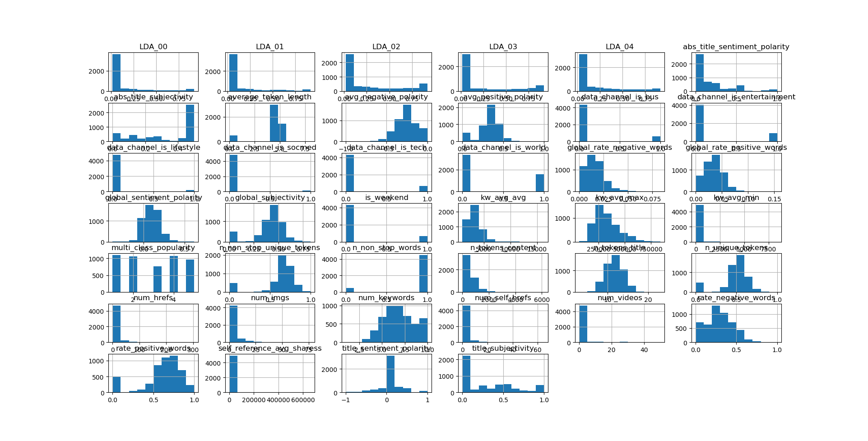

**Figure 5** – Count plot of Data

**Data Analysis:**

Questions to determine:

1. What **percentage(%)** of news will be popular depending upon value of shares.
2. Is there a huge difference between news that are **popular vs non-popular?**

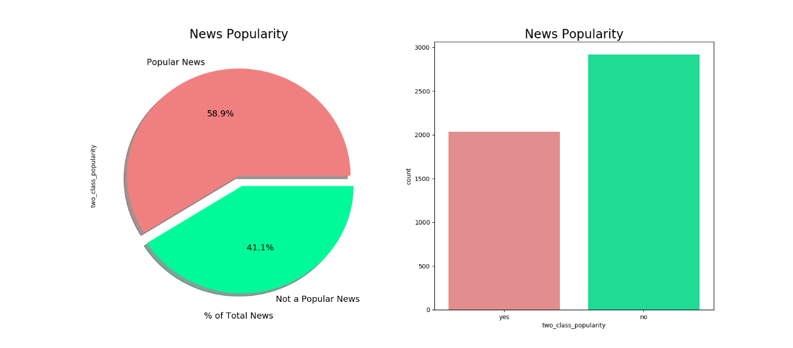

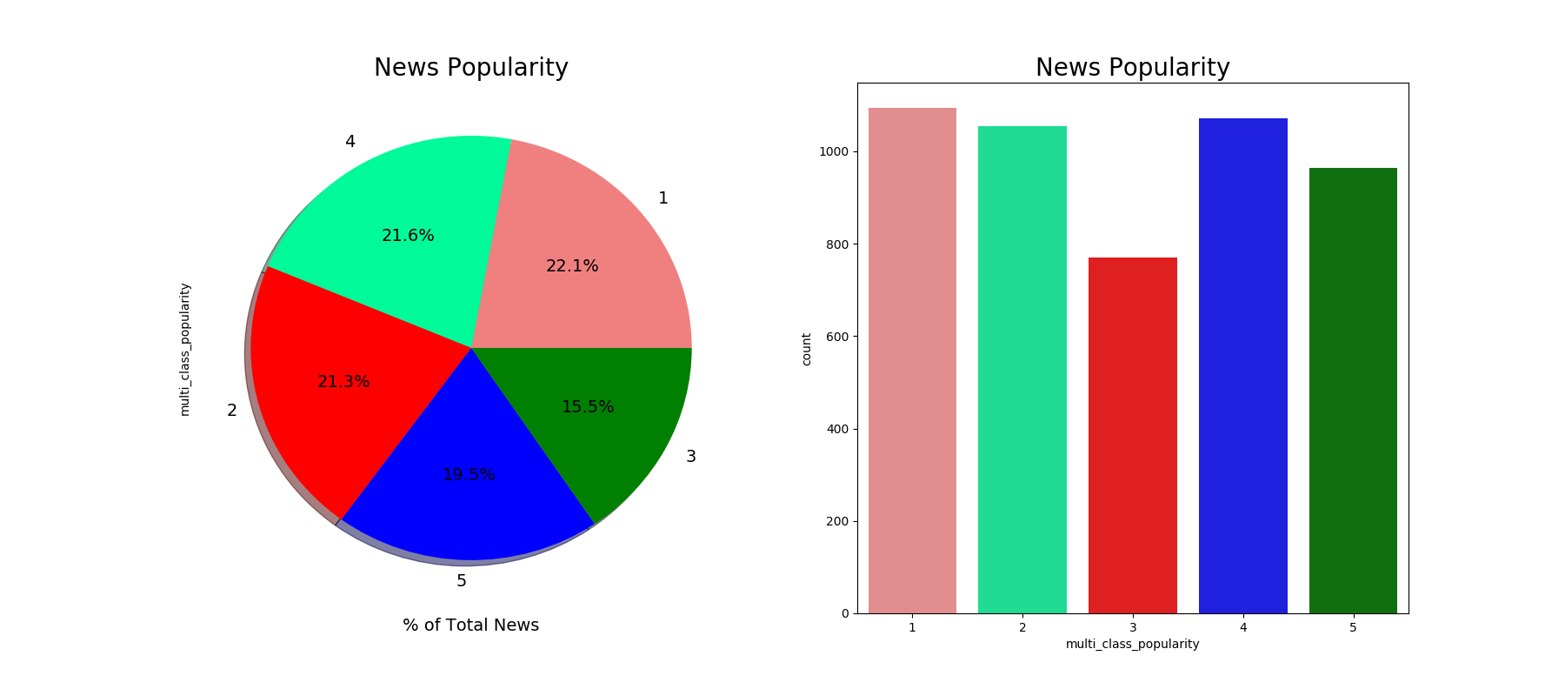

**Figure 6** – Class labels density

From given data set class labels, we can observe that **data imbalance is NOT present.**

Next Steps:

The obvious step would be to detect patterns that influence potential clients to either accept or refuse to buy term deposits. After analyzing the data, we can start with data pre-processing.

**DATA PREPROCESSING**

After data visualization, we observe certain pattern which might affect the classification.

From data interpretation, we can interpret that data has imbalance due to unequal percentage of class labels.

Categorical features in data set has missing values. Hence data imputation should be precisely to tackle these

Data needs scaling because it has very high variation from mean. Due to categorical features, we need to do one-hot encoding.

After one-hot encoding, we can observe high dimensional data. So, I have used PCA for dimension reductionality.

## **DATA IMPUTATION**

There are different solutions to tackle data imputation depending upon applications and type of data that you are imputing. From figure 4, we can see available ways to handle the data.

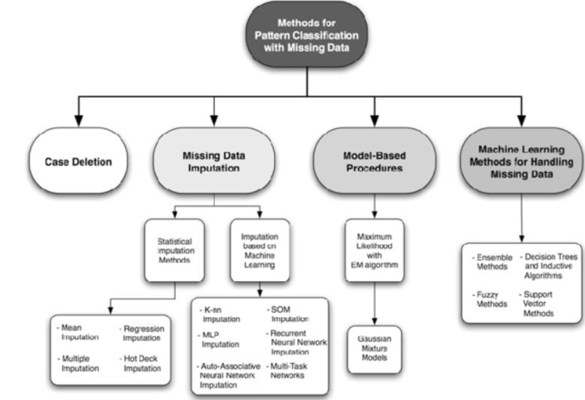

**Figure 4** – Data Imputation Methods

Median-

For median based imputing, for every feature, we change the missing value by its median of that column. Note that this method is based on feature and does not depend on class labels. This is one of the simplest way to handle data. Disadvantage of this method is we cannot impute categorical data using median method.

Mode:

Mode based imputing is similar to median where imputing is based on feature wise imputing. Mode is one of the most used and better way to imputer the data.

Random Forest:

Unlike statistical based imputing methods, we can impute data using machine learning algorithms like random forest. For every class, we convert categorical data into multivalued labels using label encoder. The features that has missing values are now used as class labels. All the samples with the unknown values are considered as the test data and the model is trained on the remaining samples. We then use RF classifier to predict the class values for missing.

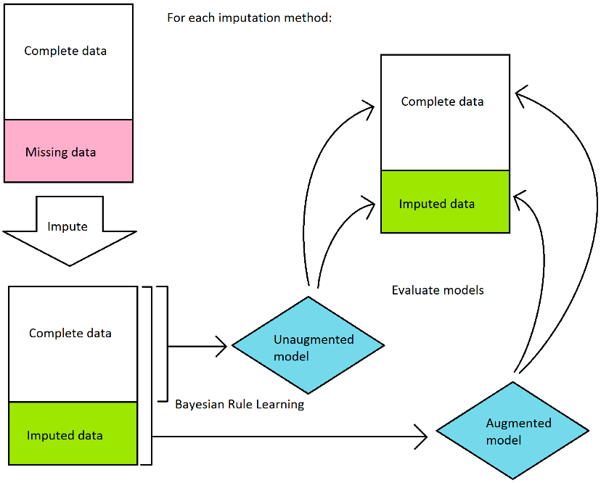

**Figure 5** – Data Imputation Model

Support Vector Machines:

Just like RF classifier, we can SVM to predict the missing values of any categorical features.

Delete:

Another popular method for handling missing data is to ignore the points which has any unknowns in any features.

From figure 5, we can observe model flow for after handling missing values. I have used **Neural Network, SVM, mode and delete** methods for data imputing.

## **ENCODING**

For categorical features, machine learning classifier cannot process the data. Hence, we need encode data in such a way that classifier understands its importance. One hot encoding is a process by which categorical variables are converted into a form that could be provided to ML algorithms to do a better job in prediction. I have used one-hot encoding. It is popular way to convert categorical data into n features with binary values.

We use one hot encoder to perform “binarization” of the category and include it as a feature to train the model.

## **DATA IMBALANCE**

Data imbalance occurs when we have more data for one class compared to another class. This is a scenario where the number of observations belonging to one class is significantly lower than those belonging to the other classes. In this situation, the predictive model developed using conventional machine learning algorithms could be biased and inaccurate. This happens because Machine Learning Algorithms are usually designed to improve accuracy by reducing the error. Thus, they do not take into account the class distribution / proportion or balance of classes.

RANDOM UNDER-SAMPLING:

Random Under sampling aims to balance class distribution by randomly eliminating majority class examples.  This is done until the majority and minority class instances are balanced out.

* **Advantages:**

1. It can help improve run time and storage problems by reducing the number of training data samples when the training data set is huge

* **Disadvantages:**

1. It can discard potentially useful information which could be important for building rule classifiers
2. The sample chosen by random under sampling may be a biased sample. And it will not be an accurate representative of the population. Thereby, resulting in inaccurate results with the actual test data set.

RANDOM OVER-SAMPLING

Over-Sampling increases the number of instances in the minority class by randomly replicating them in order to present a higher representation of the minority class in the sample.

* **Advantages:**

1. Unlike under sampling this method leads to no information loss.
2. Outperforms under sampling

* **Disadvantages:**

1. It increases the likelihood of overfitting since it replicates the minority class events.

I have used under and over sampling using **randomoversampler()** and **randomundersampler()**.

## **DATA SCALING**

Feature scaling is a method used to standardize the range of independent variables or features of data. In data processing, it is also known as data normalization and is generally performed during the data preprocessing step.

Scaling transforms the values to another range which usually includes both a shift and a change of the scale (magnification, or reduction). The data samples are transformed according to the following equation:

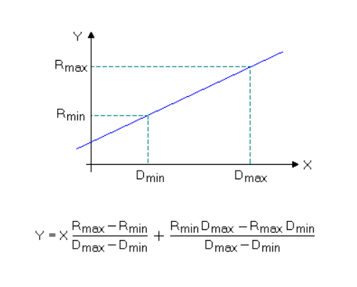

**Figure 6** – Data Scaling

Standardization (sometimes also called autoscaling, or z-transformation) is the scaling procedure which results in a zero mean and unit variance of any descriptor variable. For every data value the mean μ has to be subtracted, and the result has to be divided by the standard deviation σ (note that the order of these two operations must not be reversed):

Y = ( X - μ) / σ

I have used **StandardScalar, MinMaxScalar and RobustScalar** for data scaling and normalizing.

**CLASSIFIERS**

## **LINEAR DISCRIMINANT ANALYSIS**

Linear Discriminant Analysis (LDA) is a classification method originally developed in 1936 by R. A. Fisher. It is simple, mathematically robust and often produces models whose accuracy is as good as more complex methods.

LDA is based upon the concept of searching for a linear combination of variables (predictors) that best separates two classes (targets). To capture the notion of separability, Fisher defined the following score function.

$$Z= β_{1}x_{1}+β_{2}x_{2}+…+β_{d}x_{d}$$

Score Function,

$$S\left(β\right)= \frac{β^{T}μ_{1}+ β^{T}μ_{2}}{β^{T}Cβ}$$

$$S\left(β\right)= \frac{\overline{Z_{1}}- \overline{Z_{2}}}{Variance of Z within group}$$

Given the score function, the problem is to estimate the linear coefficients that maximize the score which can be solved by the following equations.

$$β= C^{-1}(μ_{1}-μ_{2})$$

Pooled Covariance matrix,

$$C= \frac{1}{n_{1}+n_{2}}(n_{1}C_{1}+n_{2}C_{2})$$

where, β is the linear model coefficients, C\_1,C\_2 are the covariance matrices and μ\_1,μ\_2 are the mean vectors.

One way of assessing the effectiveness of the discrimination is to calculate the Mahalanobis distance between two groups. A distance greater than 3 means that in two averages differ by more than 3 standard deviations. It means that the overlap (probability of misclassification) is quite small.

$$∆^{2} = β^{T}(μ_{1}-μ_{2})$$

Where, ∆ is the Mahalanobis distance between the two groups.

Finally, a new point is classified by projecting it onto the maximally separating direction and classifying it as C1 if:

$$β^{T}\left(x-\left(\frac{μ_{1}+μ_{2}}{2}\right)\right)> -\log{\frac{P(C_{1})}{P(C_{2})}}$$

Where, $x$ is the new datapoint, $P(C_{1})$ and $P(C_{2})$ are the class probabilities.

## **DECISION TREE LEARNING**

Decision Trees are a type of Supervised Machine Learning where the data is continuously split according to a certain parameter. The tree can be explained by two entities, namely decision nodes and leaves. The leaves are the decisions or the final outcomes. And the decision nodes are where the data is split.

There are two types of decision trees: Tree models where the target variable can take a discrete set of values are called classification trees, and Trees where the target variable can take continuous values are called regression trees.

There are many specific decision-tree algorithms, different algorithms use different metrics for measuring best split. Some examples of these metrics are: Gini impurity, Entropy, Variance reduction etc.

## **LOGISTIC REGRESSION**

In logistic regression, we model the class conditional densities by requiring that,

$$\log\left(\frac{P(1|x)}{P(-1|x)}\right)= a^{T}x$$

Where, ‘a’ is a vector of parameters.

It is straight forward to estimate ‘a’ using maximum likelihood.

Note that,

$$P\left(1 | x\right)= \frac{e^{a^{T}x}}{1+e^{a^{T}x}}$$

$$P\left(-1 | x\right)= \frac{1}{1+e^{a^{T}x}}$$

So that we can estimate the correct set of parameters a ̂ by solving for the minimum of the negative log-likelihood. That is,

$$\hat{a}={argmin}_{a}\left[\sum_{i ∈samples}{\left(\frac{1+ y_{i}}{2}\right)a^{T}x-\log\left(1+a^{T}x\right)}\right]$$

This is a convex problem and can be easily solved by Newton’s method. In fact, when we use maximum likelihood, we are choosing a classifier boundary that minimizes the loss function.

For sample i, we write $γ_{i}= a^{T}x_{i}$. Our classifier will be,

$$choose\left\{\begin{matrix}1 & γ_{i}>0 \\ -1 & γ_{i}<0 \\ random & γ_{i}=0\end{matrix}\right.$$

Now write loss for the ith sample,

$$L\left(y_{i},γ_{i}\right)= -\left[\frac{1}{2}\left(1+ y_{i}\right)γ_{i}- \log\left(1+e^{γ_{i}}\right)\right]= \log{[1+e^{{-y_{i}γ}_{i}}]}$$

This loss is known as logistic loss. We can see from the above equation that the loss strongly penalizes a large positive γ\_i if y\_i is negative (or vice versa). However, there is no significant advantage to having a large positive γ\_i if y\_i is positive. This means that the significant component of loss function will be due to the samples that the classifier gets wrong, but also due to the samples that have γ\_i near zero (that is, the sample is close to the decision boundary).

Now the total risk of applying this classifier to our set of examples is,

$$R\left(x\right)= \sum_{i ∈samples}{-\left[\frac{1}{2}\left(1+ y_{i}\right)γ_{i}- \log\left(1+e^{γ_{i}}\right)\right]}$$

## **RANDOM FOREST**

Random Forest Classifier is an algorithm that combines more than one calculations of same or diverse kind for classifying objects. Random forest classifier makes a set of decision trees from randomly chosen subset of training set. It at that point sums the votes from distinct decision trees to choose the final class of the test object. Fundamental parameters to Random Forest Classifier can be add up to number of trees to be created and decision tree related parameters like minimum split, split criteria etc. The leading highlight of random forest classifier is that even if one or few decision trees are prone to a noise, the overall result would tend to be correct.

## **SUPPORT VECTOR MACHINE**

“Support Vector Machine” (SVM) is a supervised machine learning algorithm which can be used for both classification or regression challenges. However, it is mostly used in classification problems. In this algorithm, we plot each data item as a point in n-dimensional space (where n is number of features you have) with the value of each feature being the value of a particular coordinate. Then, we perform classification by finding the hyperplane that differentiate the two classes very well.

A SVM classifier is always looking for two things: (i) larger margin, and (ii) lower misclassification rate. But if we increase the margin, we will end up having larger misclassification error. On the other hand, if we decrease the margin, we will end up having lower misclassification error. A lower error on training dataset does not guarantee a lower error on the test dataset. Therefore, to get better result on the testing dataset, SVM looks for a higher margin. The slack variable parameter C decides the width of the margin: larger value of C implies a smaller margin, and a smaller value of C implies a larger margin.

Gamma is a parameter of the RBF kernel and can be thought of as the ‘spread’ of the kernel and therefore, the decision region. When gamma is low, the ‘curve’ of the decision boundary is very low and thus the decision region is very broad. When gamma is high, the ‘curve’ of the decision boundary is high, which creates islands of decision-boundaries around data points.

## **K NEAREST NEIGHBOURS**

K-nearest neighbors can be used for classification and the result is the class membership. Here the object classification is done based on the majority votes of its neighbors, with the object being classified to the class with majority votes.

The working of the algorithm is as explained: A positive integer k is specified along with the new sample. Then we select k neighbors which are closest to the new sample based on some distance metric like Euclidean distance, Manhattan distance, Minkowski distance, Mahalanobis distance etc. Now we get the most common classification outputs from the nearest neighbors and this is the class we give to the new sample.

## **NAÏVE BAYES CLASSIFIER**

It is a classification technique based on Bayes’ Theorem with an assumption of independence among predictors. In simple terms, a Naive Bayes classifier assumes that the presence of a particular feature in a class is unrelated to the presence of any other feature.

Naive Bayes model is easy to build and particularly useful for very large data sets. Along with simplicity, Naive Bayes is known to outperform even highly sophisticated classification methods

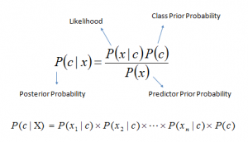

Where,

P(c|x) is the posterior probability of class (c, target) given predictor (x, attributes).

P(c) is the prior probability of class.

P(x|c) is the likelihood which is the probability of predictor given class.

P(x) is the prior probability of predictor.

## **MULTILAYER PERCEPTRON**

A multilayer perceptron (MLP) is a deep, artificial neural network. It is composed of more than one perceptron. They are composed of an input layer to receive the signal, an output layer that makes a decision or prediction about the input, and in between those two, an arbitrary number of hidden layers that are the true computational engine of the MLP. MLPs with one hidden layer are capable of approximating any continuous function.

Multilayer perceptrons are often applied to supervised learning problems: they train on a set of input-output pairs and learn to model the correlation (or dependencies) between those inputs and outputs. Training involves adjusting the parameters, or the weights and biases, of the model in order to minimize error. Backpropagation is used to make those weigh and bias adjustments relative to the error, and the error itself can be measured in a variety of ways, including by root mean squared error (RMSE).

In the forward pass, the signal flow moves from the input layer through the hidden layers to the output layer, and the decision of the output layer is measured against the ground truth labels.

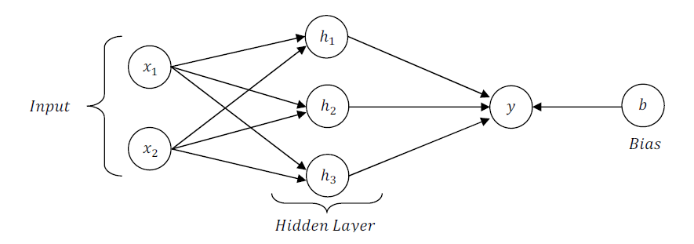

In the backward pass, using backpropagation and the chain rule of calculus, partial derivatives of the error function w.r.t. the various weights and biases are back-propagated through the MLP. That act of differentiation gives us a gradient, or a landscape of error, along which the parameters may be adjusted as they move the MLP one step closer to the error minimum. This can be done with any gradient-based optimisation algorithm such as stochastic gradient descent. The network keeps playing that game of tennis until the error can go no lower. This state is known as convergence.

**MODEL SELECTION**

## **CROSS VALIDATION**

The problem with machine learning models is that you won’t get to know how well a model performs until you test its performance on an independent data set (the data set which was not used for training the machine learning model). Cross validation helps us estimate the performance of our model. One type of cross validation is the K-fold cross validation. It helps us understand how machine learning model would generalize to an independent dataset. We in our experiment use K-fold cross validation performing following steps:

1. Divide the original training dataset into K equal parts. Each part is called a fold. Let us call them $D_{tr1}$, $D_{tr2}$, $D_{tr3}$………. $D_{trk}$.
2. Now keep the fold $D_{tr(i)}$ as validation set and keep the rest k-1 folds for training. Perform the learning on these k-1 folds and calculate the accuracy on the held-out validation set

|  |  |  |  |  |  |
| --- | --- | --- | --- | --- | --- |
| i=1 | $$D_{tr1}$$ | $$D_{tr2}$$ | $$D_{tr3}$$ | ……. | $$D_{trk}$$ |
| i=2 | $$D_{tr1}$$ | $$D_{tr2}$$ | $$D_{tr3}$$ | ……. | $$D_{trk}$$ |
| i=3 | $$D_{tr1}$$ | $$D_{tr2}$$ | $$D_{tr3}$$ | ……. | $$D_{trk}$$ |
| i=k | $$D_{tr1}$$ | $$D_{tr2}$$ | $$D_{tr3}$$ | ……. | $$D_{trk}$$ |

**Figure 7** – K Fold Cross Validation

1. Shift the validation set to new ‘i’ and repeat it such that every fold is atleast once used in validation.
2. Estimate the accuracy of your model by averaging the accuracies derived in all the k cases of cross validation.

## **FEATURE SELECTION**

F Test is a statistical test used to compare between models and check if the difference is significant between the model. F-Test is useful in feature selection as we get to know the significance of each feature in improving the model.

ONLINE DATASET

The first two attributes containing the URL of the article and time delta to data acquisition are not useful for predictions. Of the rest, many are binary attributes and by visual inspection some seem to be correlated.

For example, the “is\_weekday\_{Saturday,Sunday}, Saturday and Sunday information is aggregated into the attribute is\_weekend so, is\_weekday\_{Saturday,Sunday} can be safely removed.

Similarly, aggregating information from attributes is\_weekday\_<Monday- Friday> into a new attribute “is\_weekday” will improve quality of the explanatory attribute. This we believe will create complex attributes from simple granular ones and also the construction of excessive number of dummy attributes will be reduced for regression like approaches.

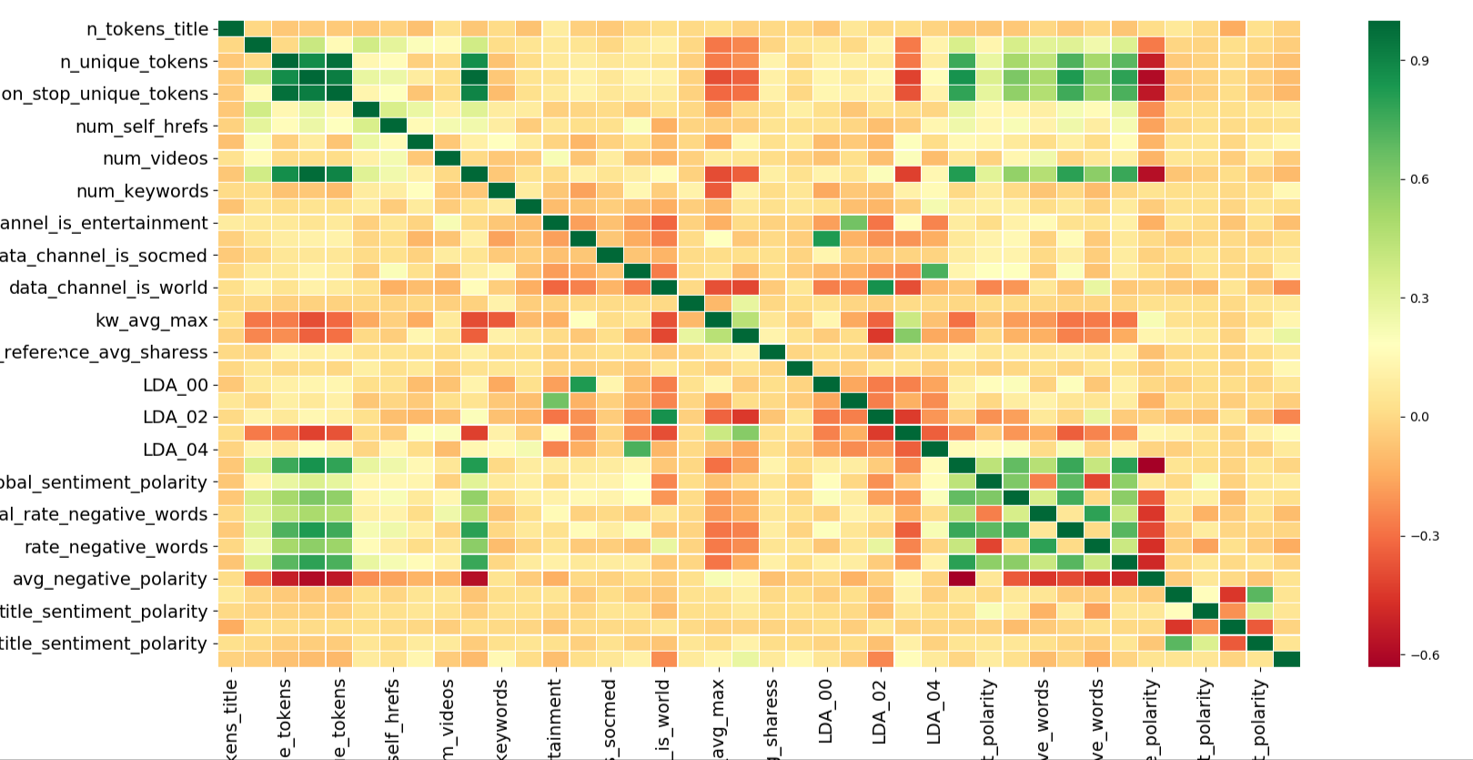

**Figure 8** – Correlation Matrix

From figure 8, we can observe correlation between features. Green indicated very high correlation. We are dropping features having high correlation as it does not help in classification as both the features has almost same information. Attributes 19-27 and 50-55, in the above table, which have information about the number of keywords and positive words. Here, the attributes are average, minimum and maximum. The average encompasses information from the minimum and maximum so, there is some collinearity between these attributes. Thus, to reduce effects of singularity we removed the attributes with suffix “\_min\_” and “\_max\_” while keeping “\_avg\_”. Thus, reducing attributes and avoiding possible ill-effects after visually inspection.

BANK DATASET

Scikit learn provides the Selecting K best features using F-Test. We used f\_classif to detect importance of features and I have used **top 50 percentile** features for classification for feature selection and parameter tuning methods.

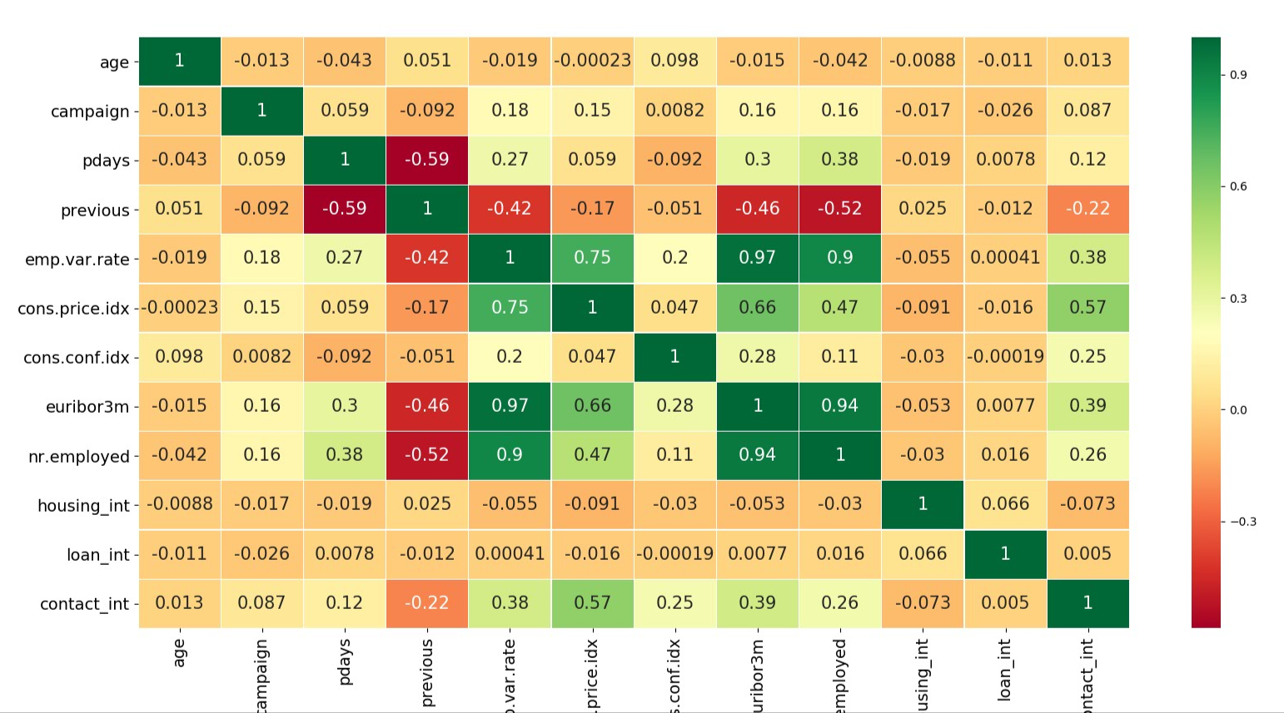

**Figure 8** – Correlation Matrix

We can observe very high positive as well as negative correlation between some features from figure 8.

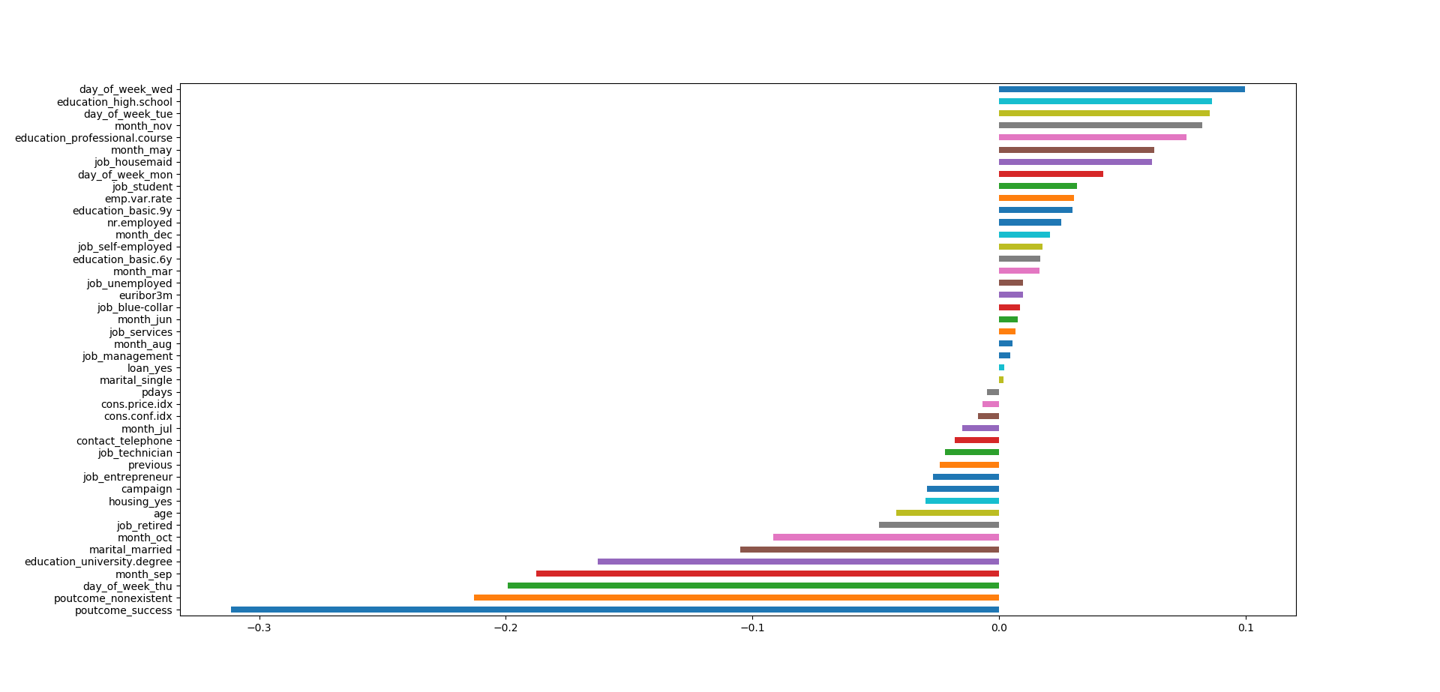

**Figure 9** – Feature Importance

## **DIMENSIONALITY REDUCTION**

Principal component analysis is a very popular dimensionality reduction technique. Here, the features are transformed into a new set of features, which are linear combination of original values. These new set of variables are known as principle components. They are obtained in such a way that first principle component accounts for most of the possible variation of original data after which each succeeding component has the highest possible variance. The principal components are sensitive to the scale of measurement, now to fix this issue we should always standardize variables before applying PCA.

## **F-TEST SCORE**

An F statistic is a value you get when you run an ANOVA test or a regression analysis to find out if the means between two populations are significantly different. It’s similar to a T statistic from a T-Test; A-T test will tell you if a single variable is statistically significant and an F test will tell you if a group of variables are jointly significant.

You can use the F statistic when deciding to support or reject the null hypothesis. In your F test results, you’ll have both an F value and an F critical value.

The F critical value is also called the F statistic.

The value you calculate from your data is called the F value (without the “critical” part).

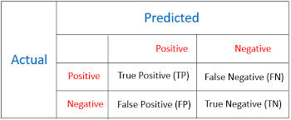

**Figure** 10– F Test representation

Depending upon all the values, we can calculate F measure.

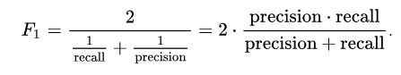

## **ROC-AUC SCORE**

In statistics, a receiver operating characteristic curve, i.e. ROC curve, is a graphical plot that illustrates the diagnostic ability of a binary classifier system as its discrimination threshold is varied. The Total Operating Characteristic (TOC) expands on the idea of ROC by showing the total information in the two-by-two contingency table for each threshold. ROC gives only two bits of relative information for each threshold, thus the TOC gives strictly more information than the ROC.

Stride: It is how much should each filter should shift for doing next convolution. We can reduce number of weights using this parameter.

Padding- We pad the image using valid (zero padding) or same (reflection padding) for the pixels around the edges.

1. ***Pooling Layer***

**Figure 4** – Pooling Layer Overview

This layer usually subsamples the output of preceding layer. It is generally used after convolutional layer. Its significant capacity is to decrease spatial size of convolutional yield picture to diminish the quantity of weights and association with a specific end goal to lessen the danger of overfit. This layer operates independently on slice of every depth resizes it using max, min or average function in the window and it has no learnable parameters. It works using mathematical functions.

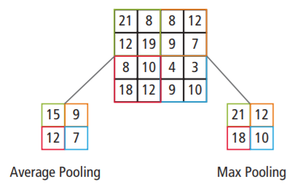

**Figure 5** – Working of Max-Pooling

For a 2\*2 window, we will discard about 75% activations output. The depth of the dimensions of input remains unchanged. It is non-linear down sampling to reduce the information and making it more robust. An example of max pooling with 2\*2 filter and stride 2 is shown in figure 5. A compact portrayal of data is done in this layer.

***Fully Connected Layer***

This layer is usually the last layer in CNN architecture. This has full associations with every one of the activation in past layer. The combined activations can be calculated using matrix multiplication and using bias offset. It generally takes input from pooling layer and output N dimensional vector where N is number of classes that depicts probability of each class.

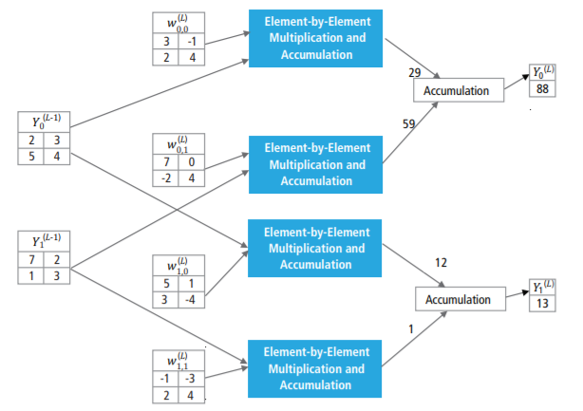

**Figure 6** – A fully connected layer

A fully connected layer checks which abnormal state highlights to the specific class and has the particular weights with the goal that we get probabilities for each class by figuring the result of weights and past layers.

1. ***The Activation Function***

The activation function of a node defined the output given set of inputs. It is non-linear function that allows us to solve difficult problems. Activation function enable us to present the non-linearity in the system. Non-linearity implies yield can't be precisely duplicated from direct mix of information. This function decided whether the neuron should get fired or not.



**Figure 7** – A single hidden layer network

For a single hidden layer network,

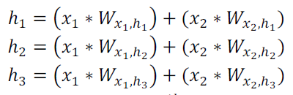

Where Wi,j are the weights between ith input layer and jth output layer. The final output ‘’y” will be



Here, substituting h1, h2, h3 in the equation above,

 

This is linear in x1, x2

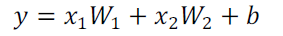

Typically, in machine learning applications, there are lot of activation function that have been used

1. Step Function-

Activation function is based on threshold.

Activation function A = 1 if y > threshold,

0 otherwise

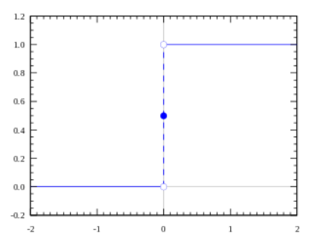

**Figure 8** – Step Function

1. Sigmoid Function-

Any real valued function is converted into 0-1 using this function. It tends to bring activation to the either side of the curve. But, it has problem of saturation and vanishing gradients. For near horizontal part of the curve, slow convergence can be observed,

|  |  |
| --- | --- |
|  |  |

**Figure 9** – Sigmoid Function

1. Tanh Function-

This is scaled sigmoid function. It has similar characteristics to sigmoid function. It is non-linear hence we can stack up the layers and it has range of -1 to 1. Gradient is stronger than sigmoid and derivatives are steeper. It also has vanishing gradient problems. It is very popular and widely used function.

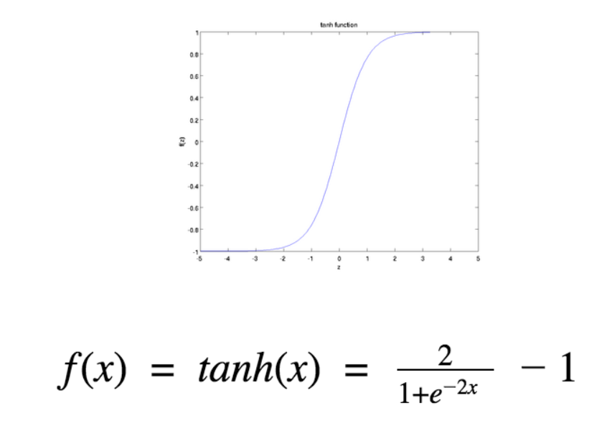

**Figure 10** – Tanh Function

1. ReLu Function-

ReLu function gives an output equal to input when input is greater than 0 and 0 if it is negative.

A(x) = max(0,x)

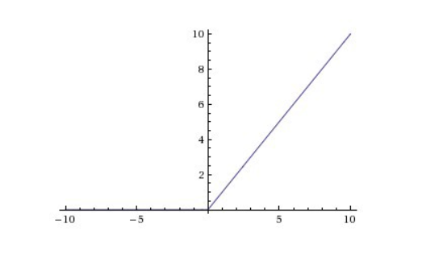

**Figure 11** – ReLu Function

ReLu is non-linear in nature. It is very good approximator as any function can be approximated using this function. The range of ReLu is o to inf means it can blow up the activation. Ideally, we want fewer neurons to fire and making the activation proficient and sparse.

Because of characteristics or ReLu, almost 50% yields 0 activation. But assume horizontal line for negative part of x, gradient can go to zero. This means ReLu has dying problem as neurons which go into zero state become irresponsive to changes in input. Henceforth, the primary thought is to give gradient a chance to be non-zero and recoup amid in the long run. It is computationally inexpensive.

1. Leaky ReLu Function-

To address the dying problem of ReLu, leaky ReLu can be used. For the negative part of x, it will have a small gradient instead of zero shown in figure.

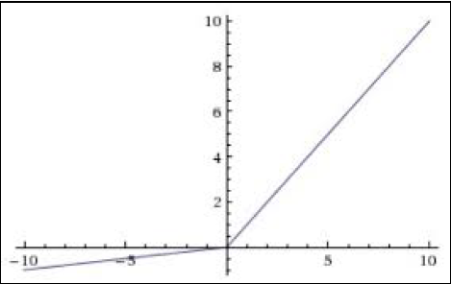

**Figure 12 –** Leaky ReLu Function

For negative part of x, it will have small constant A which makes sure Leaky ReLu will not saturate. The output is not zero centered and will converge faster.

1. Softmax function-

The softmax work is additionally a sort of sigmoid capacity however is helpful when we are attempting to deal with classification issue. It squeezes the output for each class into 0 to 1 and would also divide by the sum of outputs. This ultimately gives the probability of input being in each class. Basically, it is just the generalization of logistic regression.

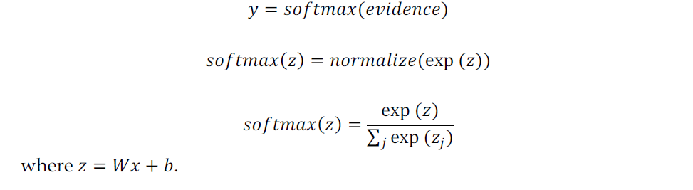

Choosing the right activation function-

Contingent on the properties of issue, we may have the capacity to settle on better decision of activation function for faster convergence.

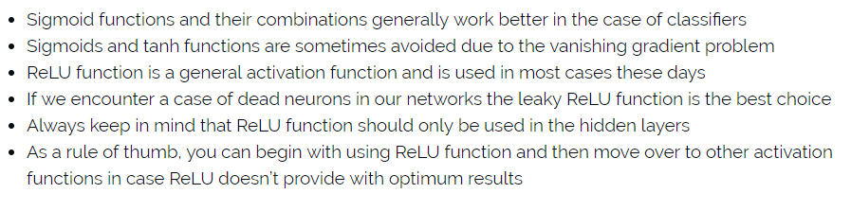

**Figure 13 –** Different activation Function

**Overfitting Issue in Model Training-**

Overfitting model alludes to show that it prepares the information too well. It, for the most part happens when model takes in the information detail and clamor too well to the degree that it hampers the execution of the model to the new data.

In statistics, overfitting is production of analysis that corresponds too closely to the training data and hence might not be able to fit the future data into trained system. An overfitted model contains more parameters that that can be justified by the data. Underfitting occurs when the network is not able to capture structure of input data adequately. An underfitted model usually has less parameters specified than that would appear in correctly specified model. This makes it inflexible to in learning the information from the dataset.

Simple learners (underfit) tends to have less variance and in the predictions but more bias towards wrong outcomes. On the other hand, complex learners (overfit) tends to have more variance in the predictions but les bias towards wrong outcomes. This is known as The Bias-Variance Tradeoff.

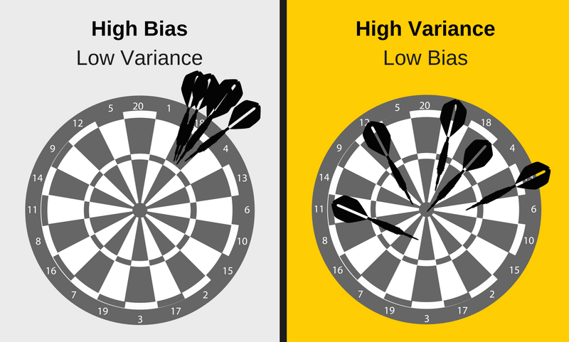

**Figure 14 –** Bias vs Variance

Overall, all the three systems can be summarized in figure 15. A decision boundary for simple, balanced and complex model can be observed below.

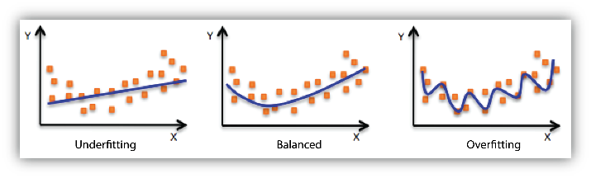

**Figure 15 –** Different predictive models

**HOW TO DETECT OVERFITTING-**

A key challenge with overfitting and with machine learning that we can’t know the performance of model until we test the data. To address this issue, we can split the input data into separate training and testing subsets.

If our model does very good on training data and performs poorly on testing data, then we are likely to have overfit model.

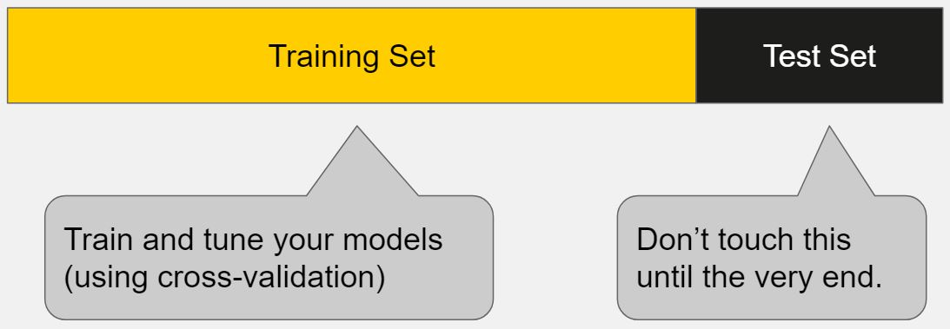

**Figure 16 –** Train-Test split

As shown in figure 16, we split the data into training and testing as validation set. Best way is to start with a very simple model to serve as benchmark. Then as you try more complex algorithms, we can compare with stated base benchmark to check whether its worth the additional complexity.

As a general rule, start by overfitting the model, then take measures against overfitting.

**Cross Validation-**

This is one of the most popular method to prevent overfitting. The basic idea is use your initial data to use many train test splits and use this data to train and validate your model.

One way to demonstrate is in your standard k-fold cross validation, we partition the data into k subsets. Iteratively, we train the model on k-1 subsets and test on remaining subset called holdout data.

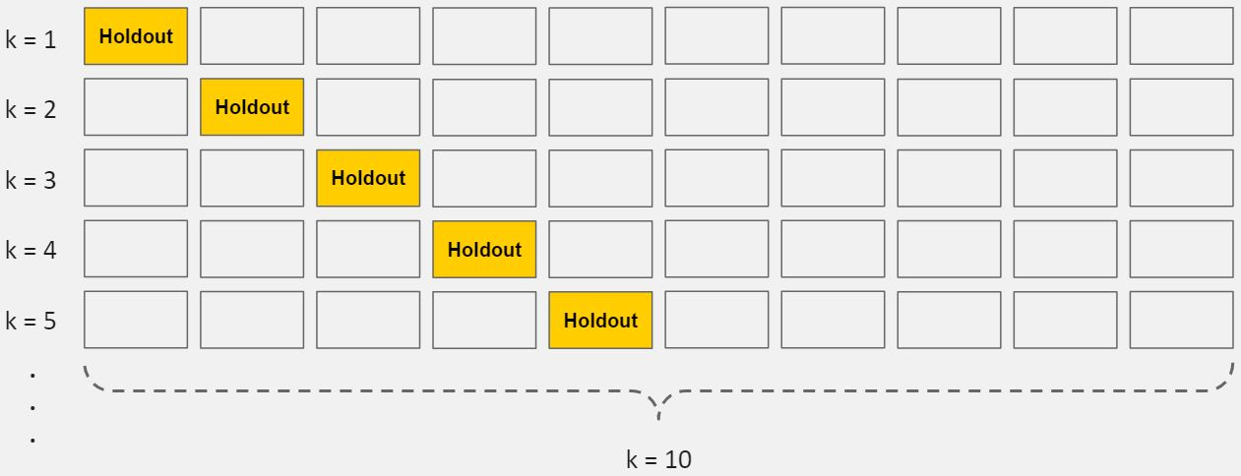

**Figure 17 –** K fold cross validation

This allows you to finely tune your parameters for the original data set which improves your maximum accuracy.

**Train with more data & Data Augmentation-**

In these methods, model might be benefitted more by training with more data sometimes. However, in most cases, this is not possible or having more data does not guarantee better performance. We have to ensure that input data is always clean and relevant to the application.

Hence, data augmentation is generally preferred where we randomly rotate, performs morphological operations, zooming and changing color filter etc. This ensures that the model get more data samples to train by augmenting or bootstrapping the data. We have to be careful by augmenting data for training only not for augmentation. Also, if we zoom so much that features of object are no longer visible, then this additional data does not help model getting more accuracy. We should not use too much data augmentation.

**Early Stopping-**

When we are training our model iteratively, we can measure the performance of every iteration. Until certain iterations, model has improvement in performance.

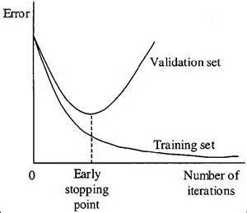

**Figure 18 –** Early stopping

As observed in figure 18, after certain iterations, model’s ability to generalize can weaken as it overfitting problem arises. So, one way to tackle this is to stop where performance is good.

**Regularization-**

Regularization refers to broad variety of techniques which tries to make model simpler. Three most popular options are dropout, L1 regularization, L2 regularization.

Dropout is most famous techniques used is almost all deep learning models. It deletes random number of activations by making them zero shown in figure 19. This reduces number of connections to the next layers which might cause loss of information but reduces chances of overfitting. Dropout prevents network from becoming dependent om any neuron. Therefore, a good practice is to start with low dropout in first layer and then gradually increasing it hence less information will be lost.

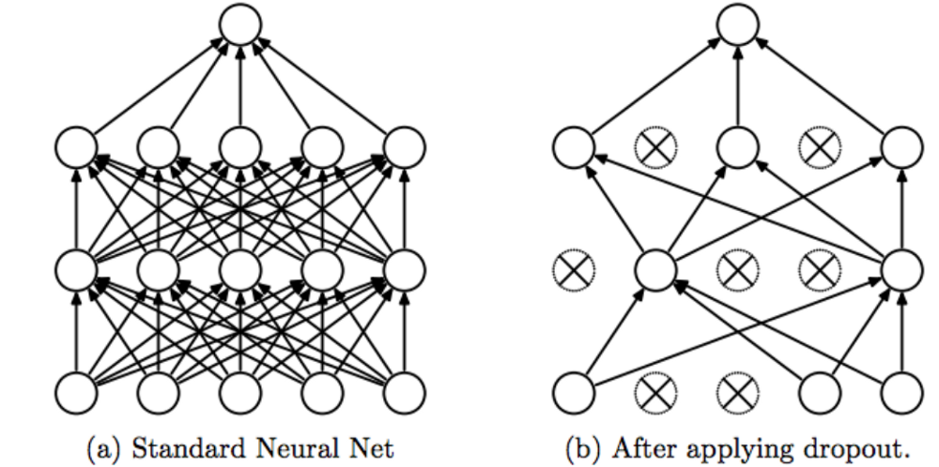

**Figure 19 –** Dropout

Another common type of regularization is *L2 regularization*. It can be implemented by increasing the error function with the squared magnitude of all weights in the neural network. In other words, for every weight w in the neural network, we add *1/2 λw^2* to the error function [2]. The basic idea to penalize peaky weight vectors and encouraging diffuse weight.

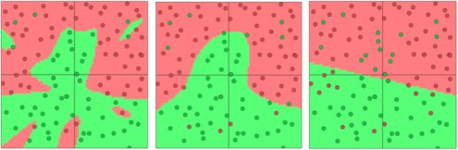

**Figure 20–** Separating the dots withL2 regularization with strengths 0.01,0.1,1

It encourages network to use all of the available weights rather than using some weights extensively. Using L2 regularization decays the weight linearly to zero. This phenomenon is known as weight decay.

Another type of regularization is L1 regularization. Here, we include the term *λ|w|* for every weight with the neural network. The *L1* regularization drives the weight vectors to become sparse amid optimization (i.e. very close to exactly zero). In other words, neurons with L1 regularization wind up utilizing just a little subset of their most essential sources of info and turn out to be very impervious to noise in the data sources [2]. We usually prefer L2 because it empirically performs better.

**COMPARISON BETWEEN CNN AND TRADITIONAL METHODS IN COMPUTER VISION-**

CNN are used in almost all the computer vision applications as it offers state of the art architecture and simplicity that helps us to solve tedious challenging problems in the field of object detection and tracking, image segmentation and classification etc.

Traditional computer vision methods for the stated applications above can be divided in to two parts mainly- feature extraction and classification. In first part, feature extraction, the process is tedious and is unique for every problem hence can-not be generalized. Hence, it requires lots of efforts and expertise in every field. Thus, second classifier is heavily dependent on feature extraction and hence classification accuracy depends on ability and knowledge of designer. This makes traditional methods less accurate and less robust.

In case of CNN, great amount of efforts has been taken and devoted to the interpretability of CNNs based on various tools and applications. Here, algorithm itself learns useful parameters and features from input.



**Figure 21–** Image classification using CNN

Consider example of image classification of birds using CNN as depicted in figure 21. Same CNN architecture can be applied to the input data of set of layers. Sequential layers learn important features and filters on its own thus making system generalized.

**Advantages of CNN-**

Robustness to shifts and distortion in the image:

CNNs are location and displacement invariant since weight configuration is similar across the image. CNN has fully connected layer to get shift invariant features. While getting the features, CNN considers variation across the image to make it invariant thereby making it robust for all applications.

Fewer memory requirements:

For any size input image, CNN uses same coefficients across different locations which results into reducing memory requirement. For traditional methods, different coefficients will be used which will result in very high memory requirement.

Easier and better training:

For traditional method like ANN and NN, training time is proportional to number of connections and parameters to be trained. But in case of CNN, since number of parameters are drastically reduced, training takes less time compared to ANN.

Highest classification accuracy:

CNN always gets highest classification accuracy using less parameters compared to the all other methods.

**THE LOSS FUNCTION-**

Loss or cost function is the function that denoted difference between actual output and desired output. The smaller the cost function is, better is our model performance.

*“A loss function or cost function is a capacity that maps an occasion or estimations of at least one factors onto a real number naturally speaking to some "cost" related to the occasion. An optimization issue looks to minimize a loss function. A target work is either a misfortune capacity or its negative (at times called a reward function, a benefit work, a utility function, a wellness work, and so on.), in which case it is to be maximized.” [3]*

To determine the loss in our model, we will be using cross-entropy given by

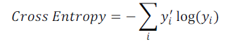

Where y′i is the ground truth label of ith training instance and yi is the prediction result of your classifier for the ith training instance.

MSE (Mean Squared Error) Loss:

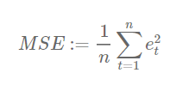

MSE is the straight line between two points in Euclidian space.

L1 Loss:

It is most intuitive loss function.

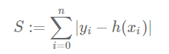

Where S is the L1 loss, yi is the ground truth and h(xi) is the inference output of your model.

**BACK PROPAGATION-**

*“The backward propagation of errors or backpropagation, is a typical technique for preparing artificial neural systems and utilized as a part of conjunction with an enhancement strategy, for example, gradient descent. The calculation rehashes a two-stage cycle, propagation, and weight update. At the point when an information vector is exhibited to the system, it is propagated forward through the system, layer by layer, until the point when it reaches the output layer. The output of the system is then compared with the coveted yield, utilizing a loss function, and an error value is computed for every one of the neurons in the output layer. The error values are then propagated in reverse(back) direction, beginning from the output, until the point that every neuron has a related error value which generally speaks to its contribution to the original output.” [4].*

When we give the input image to the network, output is passed along the layers until the final error where using loss function, we calculate the error in estimation and then it is propagated backwards through the respective neurons until every neuron in every layer has been associated with an error value which represents its contribution for the actual output.

The fundamental thought behind back-propagation is to prepare multi-layered system with the end goal that it can learn the parameters to map to output without any other contribution from input. That’s why we try to minimize the loss function is order to make best approximations.

# **Train lenet-5 on mnist dataset**

# Task: Train the CNN on MNIST dataset and discuss the settings and output.

## **ABSTRACT AND MOTIVATION**

LeNet-5 architecture is very famous and well-organized architecture presented by Yann LeCun. It is multilayers neural network trained with back-propagation algorithm with gradient based learning techniques.

## **APPROACH AND PROCEDURES**



**Figure 22–** The LeNet 5 architecture

Figure shows LeNet 5 architecture. It consists of 3 convolutional layers denoted by C1, C2 and C3 and 2 average pooling subsampling layers and lastly 2 dense layers.

Input Layer:

Input layer contains 60000 images from MNIST of dimension 28\*28 and 10000 test images. We do pad the images to make 32\*32 to use LeNet 5 architecture.

Convolutional Layer C1:

This layer contains 6 filters of size 5\*5 which are being convolved around input image to obtain 6 feature maps of 28\*28. For the high dimensional input data, number of connections would be very high hence smart option would be choosing local patch and connect that patch with output neuron. This lessens the receptive field of every neuron which is adjusted for in the following layers of this engineering. In the LeNet-5, the receptive field was chosen to be 5x5.



**Figure 23–** Convolution logic

The basic convolutional logic is explained in figure 23. The given architecture has 6 filters of dimensions 5\*5 of stride 1 with zero padding. Mode; summary in stated in the last part.

Subsampling Average Pooling Layer S2:

This layer is average pooling. In order to improve the receptive field, average pooling is used which reduces the number of weights. It has stride parameter of 2. This layer does not have any weights.

Sigmoid Activation Function:

This non-linear function is used alongside pooling layer which is applied element by element. It converts input response to 0-1 but usually has slower convergence. The reason for utilizing a non-linear activation layer is to present this non-linearity in the system. Certifiable information and procedures can be non-linear in nature. This decided which neuron should get fired and which should not.

Convolutional Layer C3:

This layer contains 16 filters of dimension 5\*5. It takes input of 6\*14\*14 and convolves 16 filters which results into 16\*10\*10 output.

Subsampling Average Pooling Layer S4:

This layer takes input from C3 layer. It averages over 2\*2 region with stride parameter of 2. This reduces dimension from 10\*10 to 5\*5 resulting 16\*5\*5.

Convolutional Layer C5:

This layer consists of 120 neurons i.e. weights. 120 filters of size 5\*5 have been used. 5\*5 convolved 5\*5 input image results into single pixels hence it contains only 120 weights.

Fully Connected Layer F6:

This is fully connected and it has 84 weights. This layer has the maximum receptive field and every neuron has the connection with input image.

Output Layer:

This is final layer consists 10 neurons representing expected output labels. We have 10 neurons corresponding to 10 numbers with activation function softmax.

Entire model summary at every step is mentioned below.

In total, network has 61706 parameters to train.

**Model Parameters:**

Batch Size:

We use mini-batch gradient descent. For every batch size, we update the weights of the network. This parameter is usually determined using brute force. Using batch training, we reduce the variance of filter weight change. It contributes towards learning rate. Larger batch size will result in slower convergence.

Learning Rate:

This parameter determines convergence time of the model. Smaller learning may converge very slowly but larger convergence may not reach global minima in the first place. These can be taken care by decaying learning rate.

Momentum:

As stated above in mini batch SGD approach, it has oscillations problems which can be harmful for convergence. Momentum is used to prevent or limit those parameters.

Drop Out:

To reduce or limit overfitting of data, dropout is usually used after sub sampling layer. It neglects certain neuron to get fired thereby reducing number of connections.

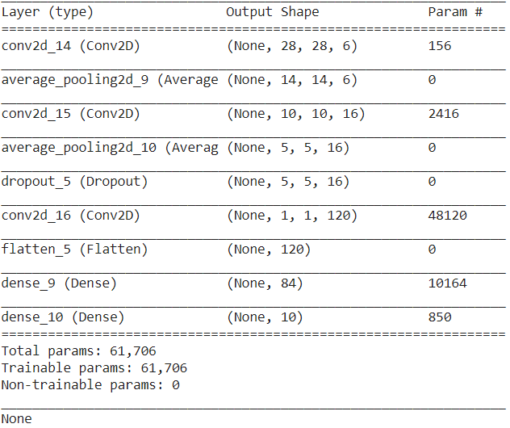

**Figure 24–** Model Summary

# **EXPERIMENTAL RESULTS**

|  |  |
| --- | --- |
| Kernel Initializer: Random Normal | Learning Rate: 0.1 Epochs: 200 |
| Momentum: 0.5 | Batch Size: 128 |

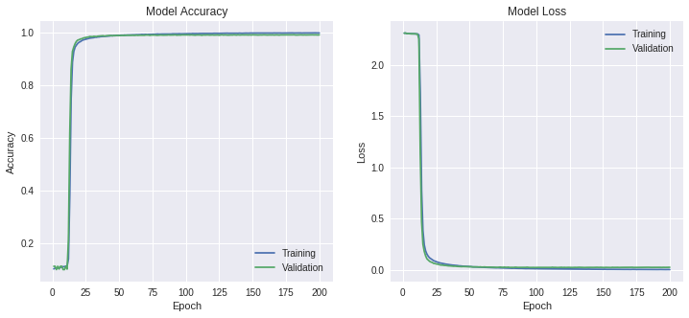

|  |  |
| --- | --- |
| Training Accuracy: 99.93 | Train Loss: 0.34 |
| Test Accuracy: 99.21 | Test Loss: 2.59 |

|  |  |
| --- | --- |
| Kernel Initializer: Random Normal | Learning Rate: 0.3 Epochs: 200 |
| Momentum: 0.5 | Batch Size: 128 |

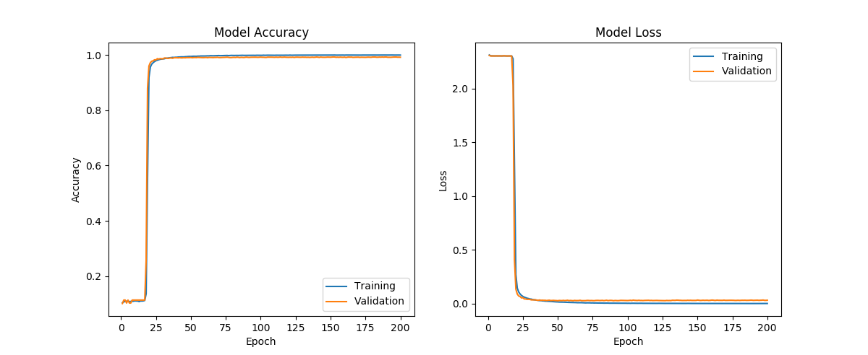

|  |  |
| --- | --- |
| Training Accuracy: 99.97 | Train Loss: 0.14 |
| Test Accuracy: 99.20 | Test Loss: 3.17 |

**Figure 25–** Accuracy and Loss curves

|  |  |
| --- | --- |
| Kernel Initializer: Random Normal | Learning Rate: 0.5 Epochs: 200 |
| Momentum: 0.5 | Batch Size: 128 |

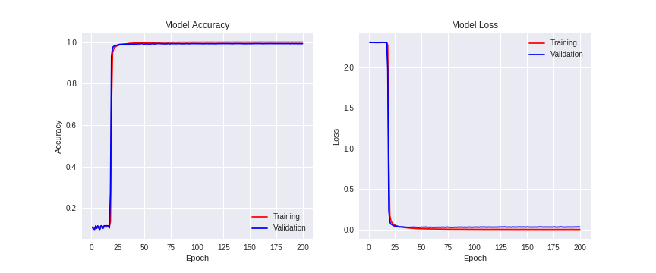

|  |  |
| --- | --- |
| Training Accuracy: 99.98 | Train Loss: 0.11 |
| Test Accuracy: 99.26 | Test Loss: 3.12 |

|  |  |
| --- | --- |
| Kernel Initializer: Random Normal | Learning Rate: 0.1 Epochs: 200 |
| Momentum: 0.25 | Batch Size: 64 |

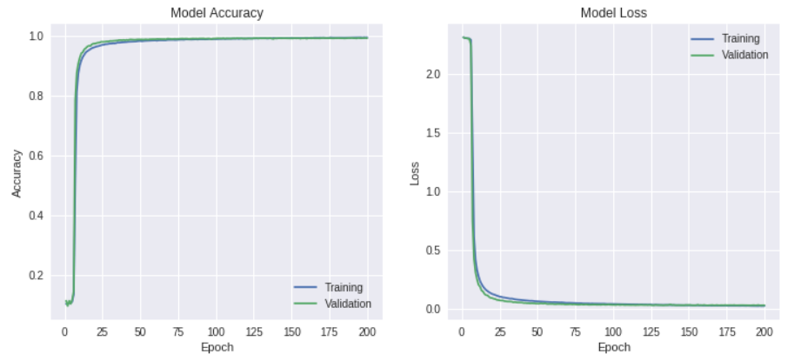

|  |  |
| --- | --- |
| Training Accuracy: 99.38 | Train Loss: 1.67 |
| Test Accuracy: 99.10 | Test Loss: 2.62 |

|  |  |
| --- | --- |
| Kernel Initializer: Default | Learning Rate: 0.1 Epochs: 200 |
| Momentum: 0.5 | Batch Size: 128 |

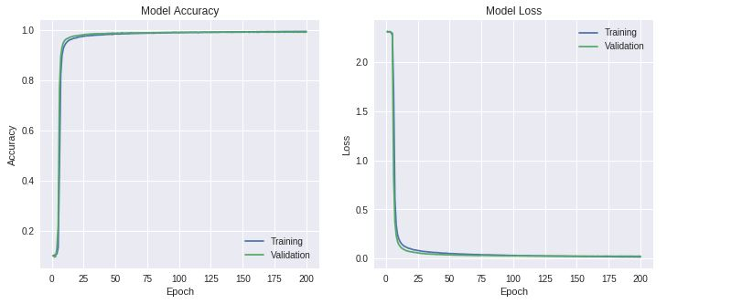

|  |  |
| --- | --- |
| Training Accuracy: 99.48 | Train Loss: 1.62 |
| Test Accuracy: 99.14 | Test Loss: 2.22 |

|  |  |
| --- | --- |
| Kernel Initializer: Default | Learning Rate: 0.3 Epochs: 200 |
| Momentum: 0.5 | Batch Size: 128 |

|  |  |
| --- | --- |
| C:\Users\HP\AppData\Local\Microsoft\Windows\INetCache\Content.Word\LeNet5-2Acc.jpg | C:\Users\HP\AppData\Local\Microsoft\Windows\INetCache\Content.Word\LeNet5-2Loss.jpg |

|  |  |
| --- | --- |
| Training Accuracy: 99.84 | Train Loss: 0.55 |
| Test Accuracy: 99.19 | Test Loss: 2.72 |

|  |  |
| --- | --- |
| Kernel Initializer: Default | Learning Rate: 0.5 Epochs: 500 |
| Momentum: 0.5 | Batch Size: 128 |

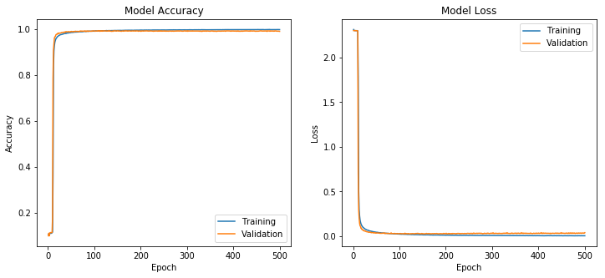

|  |  |
| --- | --- |
| Training Accuracy: 99.86 | Train Loss: 0.52 |
| Test Accuracy: 99.29 | Test Loss: 2.2 |

|  |  |
| --- | --- |
| Kernel Initializer: Default | Learning Rate: 0.1 Epochs: 200 |
| Momentum: 0.25 | Batch Size: 64 |

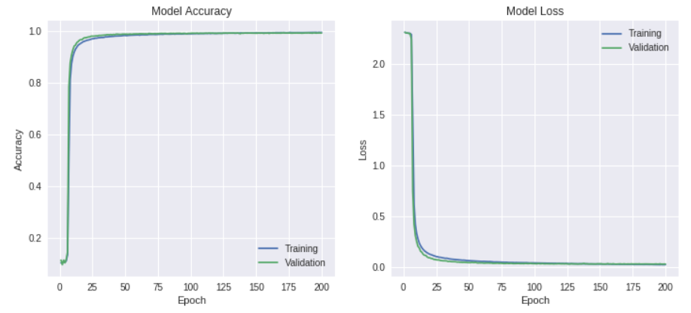

|  |  |
| --- | --- |
| Training Accuracy: 99.30 | Train Loss: 2.02 |
| Test Accuracy: 99.09 | Test Loss: 2.62 |

|  |  |
| --- | --- |
| Kernel Initializer: Default | Learning Rate: 0.1 Epochs: 200 |
| Momentum: 0.5 | Batch Size: 32 |

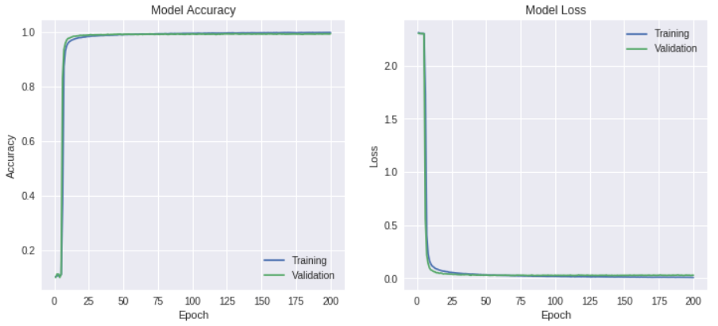

|  |  |
| --- | --- |
| Training Accuracy: 99.70 | Train Loss: 0.82 |
| Test Accuracy: 99.27 | Test Loss: 2.92 |

|  |  |
| --- | --- |
| Kernel Initializer: Random Uniform | Learning Rate: 0.1 Epochs: 200 |
| Momentum: 0.25 | Batch Size: 64 |

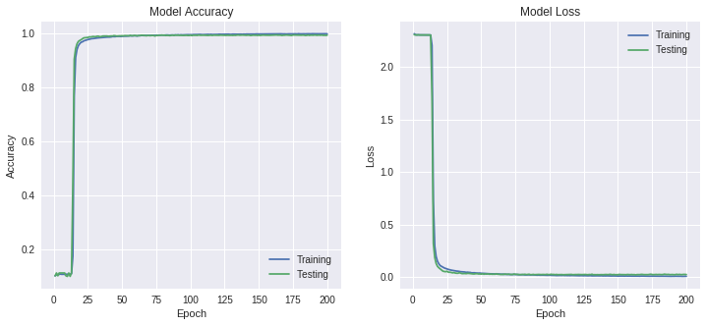

|  |  |
| --- | --- |
| Training Accuracy: 99.70 | Train Loss: 0.92 |
| Test Accuracy: 99.17 | Test Loss: 2.52 |

|  |  |
| --- | --- |
| Kernel Initializer: Random Uniform | Learning Rate: 0.1 Epochs: 100 |
| Momentum: 0.5 | Batch Size: 32 |

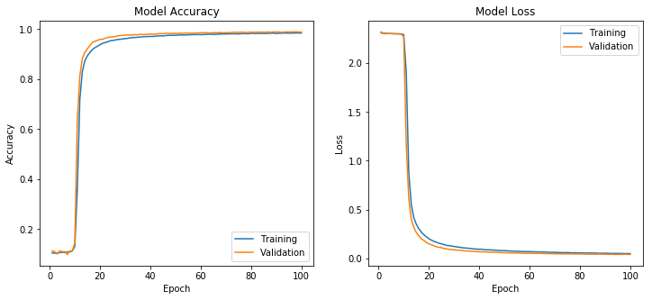

|  |  |
| --- | --- |
| Training Accuracy: 99.63 | Train Loss: 0.97 |
| Test Accuracy: 99.13 | Test Loss: 2.72 |

|  |  |
| --- | --- |
| Kernel Initializer: Random Normal | Learning Rate: 0.1 Epochs: 100 |
| Momentum: 0.5 | Batch Size: 32 |

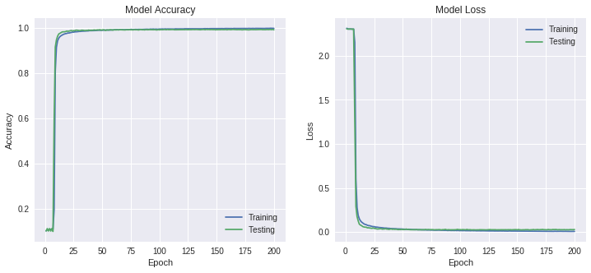

|  |  |
| --- | --- |
| **Training Accuracy: 99.73** | **Train Loss: 0.82** |
| **Test Accuracy: 99.36** | **Test Loss: 2.70** |

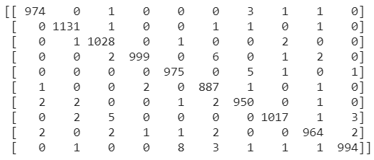

**Figure 25–** Best accuracy plot and Confusion Matrix

After best setting, I tried training and testing the model for negative (inverted) images.

|  |  |
| --- | --- |
| Image result for mnist neural negative images | Image result for mnist neural negative images |

**Figure 26–** Original and Negative images

|  |  |
| --- | --- |
| Kernel Initializer: Random Normal | Learning Rate: 0.3 Epochs: 100 |
| Momentum: 0.5 | Batch Size: 128 |

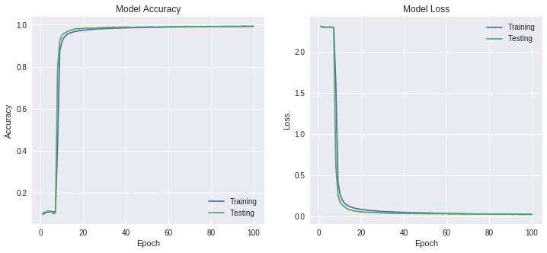

|  |  |
| --- | --- |
| Training Accuracy: 99.23 | Train Loss: 2.32 |
| Test Accuracy: 99.17 | Test Loss: 2.67 |

After this effort, I trained the network on negative image but tested the network on original images.

|  |  |
| --- | --- |
| Kernel Initializer: Random Normal | Learning Rate: 0.3 Epochs: 100 |
| Momentum: 0.5 | Batch Size: 128 |

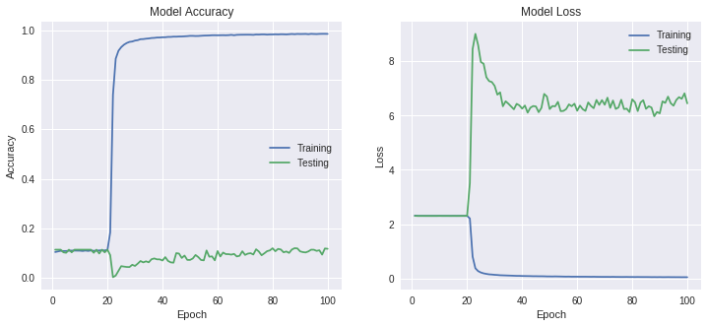

|  |  |
| --- | --- |
| Training Accuracy: 98.57 | Train Loss: 4.29 |
| Test Accuracy: 11.17 | Test Loss: 6.47 |

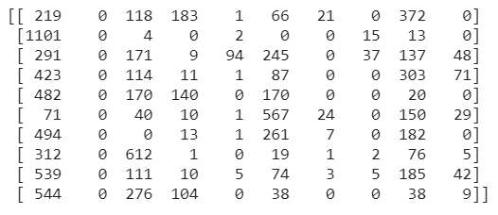

**Figure 27–** Plots and confusion matrix for negative training images

# **DISCUSSION**

I simulated LeNet 5 model using various parameters. There are various parameters like batch size, epochs, kernel initializer, learning rate, momentum and optimizers to change and I plotted training and testing accuracy as well as loss.

**Preprocessing:**

MNIST dataset contains 28\*28 image with global mean subtracted from every image as well as data was already zero centered. This prevents high-frequency components to dominate over image. As data was already pre-processed, I have just normalized the data to 0-1.

**Plots and Data Interpretation**:

From the plots shown above, initially CNN has very low accuracy and very high loss. After every iteration, it uses backward propagation to reduce the error and hence we can observe accuracy increases at some iterations and simultaneously loss decreases.

All the plots were plotted for training and testing from using tensor board. The path and link to view the outputs using tensor board has been given in the code.

Using basic LeNet 5 architecture, I maintained the architecture by tweaking few parameters to check the effect on accuracy and loss.

**Results:**

From above plots, sometimes we observe little increase in loss after certain iterations and this is known as overfitting. To tackle this problem. I have introduced dropout layer to reduce risk of overfitting. Secondly, if learning rate is very high, gradient traverse from one point to another point constantly and hence it might not be able to global optimum which is undesirable. Hence finding optimum learning rate is very optimum. Having very low learning rate results into very low convergence rate and hence takes very long time to converge. The weights are largely away from optimum value but as we reduce the error, learning rate also reduces owing to exponentially decaying function. This results into localization of global minima.

**Best Parameters:**

I have got the best training accuracy for last setting plotted in last plot. This setting is optimum versions containing perfect tradeoff between accuracy and convergence and loss parameters. We have dropout to avoid overfitting.

**Negative setting:**

When we train and test the system using negative images, results are very good and no change can be seen. But when we train the model on negative images and test the model on original images, then performance is very bad as stated in approach, CNN does not have flexibility and is not so robust

For negative images, accuracy is relatively low which indicates that CNN does not perform good for black background and white characters. This happens due to CNN’s dependency on pixel values. It doesn’t usually change the dependency that easily hence we change the training parameters to adjust for the lack of elasticity in model.

# **IMPROVEMENT OVER LENET 5 MNIST**

## **APPROACH AND PROCEDURES**

The LeNet 5 architecture mentioned above has several bad performing sections where improvement can be made.

Filter Numbers: As we increase number of filters, we get more features that improves feature efficiency and usually results into better classification. I increased number of filters from 6 to 32,64 etc.

Filter Size: I tried 3\*3, 5\*5 and 7\*7 filters. Depending upon input images, for some settings, I got better output using 3\*3 filters.

Activation Function: Because of function curve of ReLu activation function, it improves the receptiveness of network. Hence, instead of sigmoid, I used ReLu activation function everywhere because of its unique to decide whether to fire the neuron or not.

Number of Layers: I increased number of layers by adding convolutional and pooling layers and cascaded those layers to get better output.

Batch Size: Batch size is the number of training images that are being trained simultaneously. I varied batch size but this setting does not help to improve the accuracy.

Kernel Initializer: I have tried Random Normal, Random Uniform and default Glorat Normal kernels for different parameters and comparison has been shown in figure.

Optimizer: this plays most important role for improving the performance of model. I have used Adam, Adam delta and SGD. SGD has very slow convergence which can be tackled using Adam optimizer.

Drop Out: This improves the performance by making sure overfitting is being avoided.

# **EXPERIMENTAL RESULTS**

**Setting 1:**

Conv1 Filters: 50, Conv2 Filters: 100, Dense Layers: 120, 84 Activation Function: ReLu, Optimizer: Adam (lr:0.0001)

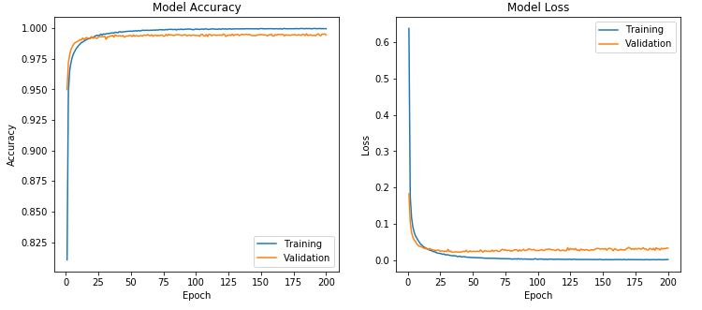

Training accuracy: 99.98%, Test Accuracy: 99.42%

**Setting 2:**

Conv1 Filters: 32, Conv2 Filters: 64, Dense Layers: 120 Activation Function: ReLu, Optimizer: Adam (lr:0.0001)

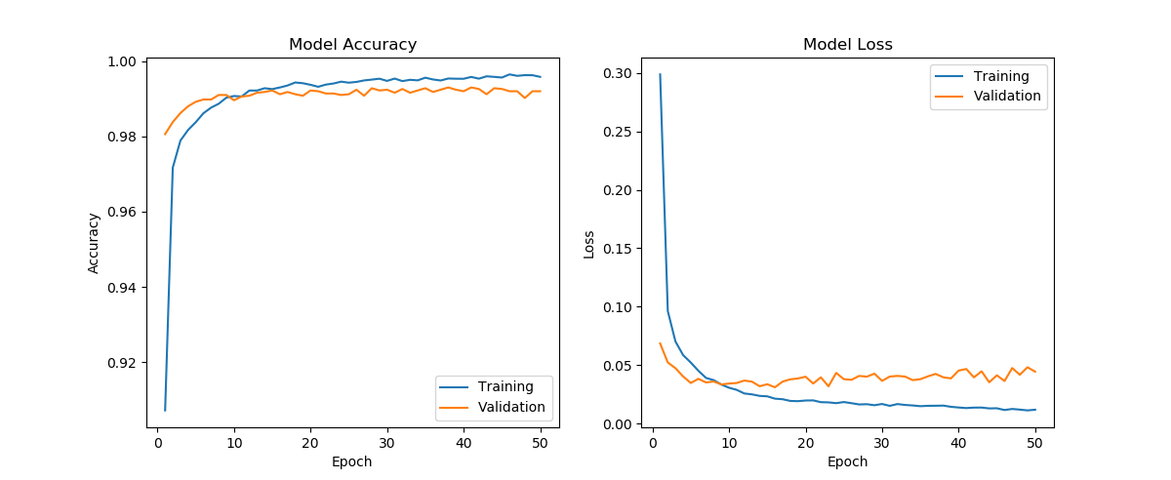

Training accuracy: 99.94%, Test Accuracy: 99.47%

**Setting 3:**

Conv1 Filters: 32, Conv2 Filters: 64, Dense Layers: 128,84,32 Dropout: 0.5Activation Function: ReLu, Optimizer: Adam



Training accuracy: 99.95%, Test Accuracy: 99.39%

**Best Setting:**

**Conv1 Filters: 32, Conv2 Filters: 64, Dense Layers: 120, 84 Activation Function: ReLu, Optimizer: Adam (lr:0.0001)**

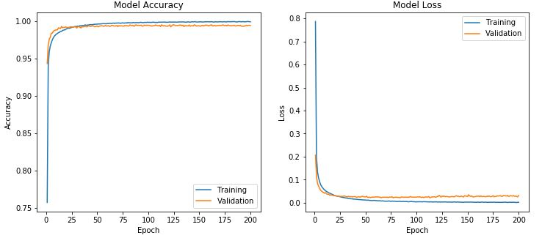

**Training accuracy: 99.97%, Test Accuracy: 99.54%**

# **DISCUSSION**

I have stated different parameters that I tinkered with to check their effect on performance.

Batch Size:

I varied batch sizes from 32 to 128 for different parameters and found out that in does not affect to an extent to the accuracy and convergence.

Epochs:

**PROBLEM 2 – SAAK TRANSFORM**

# **COMPARISON BETWEEN SAAK TRANSFORM AND CNN**

Task: Understand the SAAK transform and compare SAAK transform and CNN

## **ABSTRACT AND MOTIVATION**

SAAK (Subspace approximation with augmented kernels) transform is an efficient and robust method to recognize and classify handwritten digits recognition problem. The basic idea behind the SAAK transform is it uses multiple stages to extract group of SAAK coefficients for input image and use these coefficients to classify the input using classifier like support vector machine, random forest etc.

## **APPROACH AND MOTIVATION**

SAAK transform consists of 2 steps- subspace approximations and kernel augmentation. To achieve optimal subspace approximation, it analyzes and selects best orthonormal eigenvectors from set of available covarinace matrix as transform kernels. Here, the problem faced is usually the training data space is very large hence multiple transforms are cascaded. While cascading multiple stages of trasnform, sign confusion arises hence rectified linear unit (ReLu) activation function to limit the confusion. But due to non-linearity about activation function, there is some information loss and that can be tackled by kernel augmentation. Hence, after every SAAK stage, we get both original and augmented kernel.



**Figure 28–** SAAK transform approach

Kernel augmentation can be performed using augmenting with negative kernels. The integration of kernel augmentation and ReLu is similar to S/P format conversion of SAAK coefficients. So this way, we are able to cascade different stages to transform images of exceptionally high sizes and dimensionality.

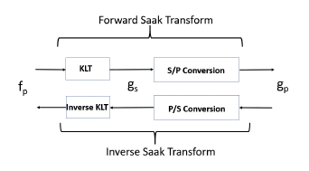

**Figure 29–** SAAK transform block diagram

Multi-stage SAAK transform offers full spatial and spectral domain representation. The

If number of classes in fixed, then end-to-end system like CNN has better optimized cost function and filter weights. However, even from small perturbations in input data, we have to train CNN once again. But for SAAK method, it has very good robustness for small changes in data because KLT transform is invariant to small shifts hence you do not need to find features again. The small change will not affect leading last-stage Saak coefficients

If we change number of classes in final layer, we need to train the system once again as number of neurons change in the last layer. However, for SAAK transform, it is against intuition filter weights for feature extraction part from SAAK does not change as they both are not dependent upon other parts.

CNN needs very large training data set and takes long time and is computationally inefficient. On the other hand, SAAK takes less computations to train and is computationally efficient. This statement has been explained in detail in results section.

Generative model vs Inverse Transform:

Since the kernel of SAAK transform are orthonormal basis, its corresponding inverse transform can be easily computed. Hence, cascading of forward and inverse transform shown in figure 30. It makes an identity operator. But on the other side for CNN, Generative Adversarial network(GAN) has to be trained first and then using encoder and decoder, we can generate the stage-wise images.

Theoretical Foundation:

CNN has sequential model and cascaded filters along every layer. The problem with CNN is visualization of responses from every filter is lacking and since we don’t know what are the stage wise responses, its very difficult to keep the track of the output. As the complexity of CNN increases, behavior of model and filter responses become intractable. On the contrary side, SAAK transform has algebraic base and supported by proper statistics. At every stage, SAAK transforms are well explained.

Filter Weights and Feature Selection:

CNN learns best filter weights optimizes them by processing data and its associated labels. It optimizes by reducing the error by back-propagation. In SAAK transform, it selects its augmented kernel using KLT at every stage. It doesn’t need any data and its associated label. Hence back-propagation is also not required. Kernel selection is based upon second-order statistics of data. Data labels are only needed in classification part, not for the feature extraction.

Efficiency:

For any given dataset, SAAK transform has better classification accuracy for minimal data for training. The comparison table has been shown in result section. CNN requires huge amount of data to train in order to produce very high accuracy output. While SAAK produces very good output even when training data is very low in amount.

# **APPLICATION OF SAAK TRANSFORM TO MNIST DATASET**

Task: Train and test the MNIST dataset using SAAK transform method

## **EXPERIMENTAL RESULTS:**

|  |  |  |  |  |
| --- | --- | --- | --- | --- |
|  | Support Vector Machines | | Random Forest | |
| PCA Components | Training Acc | Testing Acc | Training Acc | Testing Acc |
| No PCA used | 97.34 | 94.30 | Can-not run | On CPU |
| **32** | **99.22** | **98.32** | **99.92** | **93.40** |
| 64 | 98.87 | 98.20 | 99.57 | 92.37 |
| 128 | 98.02 | 97.60 | 99.31 | 90.70 |

|  |  |  |  |  |
| --- | --- | --- | --- | --- |
| PCA = 32 | Support Vector Machines | | Random Forest | |
| Train Data Size | Training Acc | Testing Acc | Training Acc | Testing Acc |
| 10000 | 99.07 | 96.79 | 99.87 | 88.96 |
| 20000 | 99.10 | 97.48 | 99.90 | 90.77 |
| 30000 | 99.20 | 97.86 | 99.91 | 92.23 |
| 40000 | 99.23 | 98.13 | 99.93 | 92.67 |
| 50000 | 99.21 | 98.20 | 99.91 | 92.81 |
| **60000** | **99.22** | **98.32** | **99.92** | **93.40** |

## **DISCUSSION**

I have trained the 60000-input data and tested the system on 10000 test data. SAAK coefficients obtained were of dimensions 2048 due to filter importance. For every stage, I used **4,12,10,20,16** important components which gave me feature vector consisting of **2048** features. Table shows training and testing accuracy for SVM and Random Forest classifier using PCA for different components and without using PCA as well. From Table 1, we can deduce 3 points. I have used **F-test score** measure or chi\_sqaure test to find best **1000** features out of features at every stage then used only those important features while moving forward with next stage.

I have feature vector of dimension 2048. If I don’t use PCA for dimensionality reduction, I am getting very good training and testing accuracy for SVM. Random forest classifier is computationally expensive and system crashes when tried to run the code using CPU for windows. As I implement PCA for stated component, my training and testing accuracy slowly starts decreasing as I increase the number of components in PCA.

Comparison between SVM and RF can be observed from the table. SVM performs very well where Random Forest algorithm has overfitting issue as it has high training accuracy but relatively low testing accuracy. We can tackle overfitting by various ways stated in first question. Random Forest works well with a mixture of numerical and categorical features. When features are on the various scales, it is also fine. Roughly speaking, with Random Forest you can use data as they are. SVM maximizes the "margin" and thus relies on the concept of "distance" between different points. As a consequence, one-hot encoding for categorical features is a must-do. Further, min-max or other scaling is highly recommended at preprocessing step.

Best classification score for both the table

In second table, for 32 components using PCA, I have calculated training and testing accuracy for different size of data used. Table shows that SAAK performs exceptionally good even with less amount of data is available to train whereas CNN requires very high amount of data to be trained in order to give very good classification accuracy. I am getting highest accuracy for all the 60000 images for training data set but even compared with very small train and test data set, it still performs very good.

This is one of the main advantages of SAAK transform over CNN.

Comparing performance of CNN with SAAK, SAAK offers robustness, scalability and requires less amount of training data to get similar classification accuracy.

When introduced any sort of noise in an image or when noisy images are being used to train and test the model, SAAK has better performance than CNN which can be supported by the result table given in [1]. For negative images (inverted images), CNN performs very poorly as shown in part b of question 1. Whereas for SAAK, during KLT transform, we augment the kernel using its negative part to take care of negative training images so that at every stage, we have original and augmented kernel which can be used for original or inverted images.

**ERROR ANALYSIS**

Task: Compare and comment on classification error cases and propose method to improve performance of CNN and SAAK.

## **EXPERIMENTAL RESULTS**

|  |  |
| --- | --- |
| C:\Users\HP\AppData\Local\Microsoft\Windows\INetCache\Content.Word\cm_2.png | C:\Users\HP\AppData\Local\Microsoft\Windows\INetCache\Content.Word\cm_1.png |



**Figure 31–** Classification error representation

**REFERENCES**

[1] https://www.analyticsvidhya.com/blog/2017/03/imbalanced-classification-problem/

[2] https://en.wikipedia.org/wiki/Decision\_tree\_learning

[3] https://adeshpande3.github.io/adeshpande3.github.io/A-Beginner%27s-Guide-To-Understanding-Convolutional-Neural-Networks/

[4] https://en.wikipedia.org/wiki/Loss\_function

[5] <http://adventuresinmachinelearning.com/keras-tutorial-cnn-11-lines/>

[6]https://machinelearningmastery.com/handwritten-digit-recognition-using-convolutional-neural-networks-python-keras/

[7]https://www.researchgate.net/publication/320727652\_A\_Saak\_Transform\_Approach\_to\_Efficient\_Scalable\_and\_Robust\_Handwritten\_Digits\_Recognition

[8] On Data-Driven Saak Transform (arXiv:1710.04176v2 [cs.CV] 14 Oct 2017)

[9] https://machinelearningmastery.com/improve-deep-learning-performance/